Adventist University of Central Africa

AI-BASED INTERNSHIP CANDIDATE SELECTION SYSTEM
Case Study: Mastery Hub of Rwanda

A final Year Project Presented in partial fulfillment of the requirements for the degree of BACHELOR OF SCIENCE IN INFORMATION TECHNOLOGY

Major in
Software Engineering

By
Ntarindwa Nshuti Allan

June, 2026

ABSTRACT
A Final Year Project for the Bachelor’s Degree in Information Technology Major in Software Engineering
Adventist University of Central Africa
TITLE: AI-Based Internship Candidate Selection System
Name of Researcher: Ntarindwa Nshuti Allan
Name of the Faculty Advisor: RUGWIZA Jean Eric
Date Completed: June 2026
The AI-Based Internship Candidate Selection System was developed to address selection challenges at Mastery Hub of Rwanda caused by the lack of a centralized platform, which reduces transparency, efficiency, and trust. The project aims to provide a simple, affordable intelligent system that automates the entire selection process from application submission to final decision.
The system is a web platform for collecting student applications and supporting documents, with AI-powered scoring and ranking. Built using React.js, Spring Boot, PostgreSQL, and Python (Scikit-learn), it integrates JWT, Google OAuth 2.0, Twilio SMS, and Gmail SMTP for authentication and notifications.
Data was gathered through observation, interviews, and document analysis. The system was designed using an object-oriented approach with UML diagrams such as use case, class, sequence, and activity diagrams. It was built with React.js, Spring Boot, and PostgreSQL, with a database covering users, applications, programs, AI scores, reviews, votes, and fairness reports.
System requirements were gathered through documentation review, observation, and stakeholder interviews. Agile methodology guided development. The system unifies application management, AI-based evaluation, digital voting, and automated notifications to improve transparency, efficiency, and reliability over manual methods.

DECLARATION
I, NTARINDWA Nshuti Allan, with Registration Number 26440, a student at the Adventist University of Central Africa in the Faculty of Information Technology, Department of Software Engineering, do hereby declare that this final year project report entitled “AI-Based Internship Candidate Selection System” is entirely the real reflection of my own original work and experience to the best of my knowledge. It has never been either partially or wholly presented in any university or any higher learning institution for the award of a degree or any other qualification.
Signature: ..............................................
Date: ........................./............./...............

APPROVAL
I, RUGWIZA Jean Eric, hereby certify that Student NTARINDWA Nshuti Allan, with registration number 26440, in the Faculty of Information Technology, Department of Software Engineering, has completed this Final Year Project report under my supervision and is hereby submitted with my approval.
Signature: …………………………
Date: ………../……………/………..

DEDICATION
With great pleasure, I dedicate this final year Project
To my supervisor for his kind guidance.
To all my friends and colleagues,
To my friend Ganza Jules
To all my family members,
To my lovely parents,

TABLE OF CONTENT
ABSTRACT i
DECLARATION ii
APPROVAL iii
DEDICATION iv
TABLE OF CONTENT v
LIST OF FIGURES viii
LIST OF TABLES x
LIST OF ABBREVIATIONS xi
ACKNOWLEDGEMENTS xii
CHAPTER 1 1
GENERAL INTRODUCTION 1
Introduction 1
Background of the study 2
Statement of the Problem 3
Choice and Motivation of the Study 5
Objectives of the Study 6
General Objective 6
Specific Objectives 6
Scope of the Study 7
Methodology and techniques used in the Study 8
Expected Results 11
Organization of the Work 12
CHAPTER 2 13
ANALYSIS OF CURRENT SYSTEM 13
Introduction 13
Description of Current System environment 14
Historical Background 14
Vision 14
Mission 14
Description of the Current System 15
Analysis and Modeling of the Current System 17
Modeling of the Current System 18
Problems of the Current System 20
System Requirements 24
Functional Requirements 24
Non-Functional Requirements 25
CHAPTER 3 26
REQUIREMENTS ANALYSIS AND DESIGN OF THE NEW SYSTEM 26
Introduction 26
Analysis and Design Methodology 27
Object-Oriented Methodology 28
Unified Modelling Language (UML) 29
Design of the New System 30
Use Case Diagram of the System 33
Class Diagrams 39
Sequence Diagrams 40
Activity Diagrams 44
Database Diagrams 45
Data Dictionary 47
System Architecture Design 49
CHAPTER 4 50
IMPLEMENTATION OF THE NEW SYSTEM 50
Introduction 50
Technologies Used 51
Frontend 51
Backend 51
Presentation of the New System 53
Software Testing 82
Unit Testing 82
Performance Testing 84
Security Testing 84
Hardware And Software Requirements 85
Client-Side Software Requirements 85
Server-Side Hardware Requirements 86
CHAPTER 5 87
CONCLUSIONS AND RECOMMENDATIONS 87
Conclusions 87
Recommendations 88
REFERENCES 90
Books 90
Journals 90
Websites 90
APPENDICES 91
Data Collection Letter 92
Case Study Organization Approval Letter 93
Curriculum Vitae 94

LIST OF FIGURES
Figure 1: Modelling of the current system 18
Figure 2: Ai-Based Internship Selection System Use Case Diagram 33
Figure 3: Class Diagram 40
Figure 4: Sequence Diagram - Student Application Submission 42
Figure 5: Sequence Diagram - AI Scoring 42
Figure 6: Sequence Diagram : Committee Member Voting 43
Figure 7: Sequence Diagram : Program Manager Final Decision 43
Figure 8: Full System Activity Diagram 44
Figure 9: Database Schema Diagram 46
Figure 10: System Architecture Diagram 49
Figure 11: Landing page 53
Figure 12: Login Page 54
Figure 13: Registration page 55
Figure 14: Student dashboard 56
Figure 15: Program Discovery and Search Interface 57
Figure 16: Application Submission Wizard (Step 1 - Your Profile) 58
Figure 17: Application Submission Wizard (Step 2 - Documents) 59
Figure 18: Application Submission Wizard (Step 3 - Review & Submit) 60
Figure 19: Program Manager Dashboard 61
Figure 20: AI-Ranked Applicants Interface 61
Figure 21: Reviewer Dashboard 62
Figure 22: Committee Discussion Forum Interface 63
Figure 23: Digital Voting Interface 64
Figure 24: System Administrator Dashboard 65
Figure 25: User Management Interface 66
Figure 26: All Applicants Report 67
Figure 27: Approved / Granted Applicants Report 68
Figure 28: Denied Applicants Report 69
Figure 29: Applied Applicants Report 70
Figure 30: Grant Award Letter (Downloadable PDF Document) 71
Figure 31: Grant SMS Notification 72
Figure 32: Denial Notification Letter (Downloadable PDF Document) 73
Figure 33: Denial SMS Notification 74
Figure 34: Fairness Monitoring Dashboard 75
Figure 35: AI Fairness & Ethical Audit Dashboard 76
Figure 36: Student Profile - Personal Information 77
Figure 37: Student Profile - Education & Academic Information 78
Figure 38: Student Profile - Documents & Identity 79
Figure 39: Document Validation - Cover Letter Content Mismatch 80
Figure 40: Document Validation Error - Transcript Name Mismatch 81

LIST OF TABLES
Table 1: Use Case Description for Student 34
Table 2: Use Case Description for Student - Track Status 35
Table 3: Use Case Description for Program Manager - Create Program 36
Table 4: Use Case Description for Program Manager - Grant/Deny Decision 37
Table 5: Use Case Description for Reviewer 37
Table 6: Use Case Description for Reviewer - Cast Vote 38
Table 7: Use Case Description for System Administrator 39
Table 8: The notations and their definitions 41
Table 9: Symbols for Database Diagram 45
Table 10: Data Dictionary - students Table 47
Table 11:Data Dictionary - applications Table 48
Table 12: Data Dictionary - ai_scores Table 48
Table 13: Data Dictionary - final_decisions Table 48
Table 14: Unit testing results for individual system modules 82
Table 15: Integration testing results for component communication 83
Table 16: Functional testing results for end-to-end system workflows 84
Table 17: Performance testing metrics for system responsiveness and efficiency 84
Table 18: Security testing results for authentication, access control, and data protection 84

LIST OF ABBREVIATIONS
AI Artificial Intelligence
API Application Programming Interface
AUCA Adventist University of Central Africa
DB Database
GPA Grade Point Average
IDE Integrated Development Environment
IT Information Technology
JWT JSON Web Token
MFA Multi-Factor Authentication
OOP Object-Oriented Programming
SDLC Software Development Life Cycle
SMS Short Message Service
SMTP Simple Mail Transfer Protocol
UAT User Acceptance Testing
UI User Interface
UML Unified Modeling Language
URL Uniform Resource Locator

ACKNOWLEDGEMENTS
First and foremost, I wish to express my heartfelt thanks to Almighty God for His grace, protection, wisdom, and strength throughout my academic pursuits. It is only because of His guidance and blessings that I have been able to complete this final year project successfully.
I extend my sincere gratitude to the Adventist University of Central Africa and all its faculty and staff, especially the Faculty of Information Technology and the Department of Software Engineering, for creating a conducive learning atmosphere. The knowledge, skills, and foundations that I received at AUCA have greatly aided my development.
I express my deepest gratitude to my supervisor, RUGWIZA Jean Eric, who provided me with invaluable guidance, counsel, and encouragement throughout this project. It is owing to his expertise and dedication that this project could be completed so effectively.
I would like to thank my parents, who have shown me unwavering love, encouragement, prayers, and moral support throughout my educational journey. The efforts and sacrifices they have made, and their trust in me, have formed the root of my success.
I also acknowledge the encouragement, understanding, and emotional support I received from my siblings. These played an important role in helping me persevere when faced with difficult conditions.
I extend my sincere appreciation to my classmates, colleagues, and friends for their cooperation, shared experiences, teamwork and moral support throughout the course of my studies. Their encouragement and companionship made my academic journey more meaningful and enjoyable.
Lastly, I would like to express my sincere gratitude to everyone who contributed directly or indirectly to the successful completion of this project. Your support, guidance, and encouragement are deeply appreciated and did not go unnoticed.

May God bless you all abundantly.
Ntarindwa Nshuti Allan

CHAPTER 1

GENERAL INTRODUCTION

Introduction
Mastery Hub of Rwanda is an innovative organization that supports student development through internship programs in Kigali. Established in 2018 to create educational and professional opportunities for Rwandan students, the organization partners with educational institutions and corporate sponsors to provide valuable learning and career experiences. According to the organization's official documentation, its mission is to equip students with the skills and support needed to succeed in Rwanda's evolving economy (Mastery Hub of Rwanda, n.d.).
A critical but often neglected aspect of student support is the fair and transparent selection of candidates for limited opportunities. The process of evaluating qualifications, comparing applicants, and matching candidates to programs must be conducted with integrity. Fairness is essential for maintaining trust among applicants, donors, and partners. Without transparency, organizations risk losing credibility and overlooking deserving candidates. However, the current process at Mastery Hub is manual, fragmented, and opaque. This creates inefficiencies including delayed decisions, inconsistent evaluation, lost documents, limited feedback, and increased staff workload.
The AI-Based Internship Candidate Selection System is a fully functional prototype web application designed and developed to digitize and automate the selection lifecycle. It transitions from a paper-based workflow to a centralized digital platform with artificial intelligence capabilities. The system provides real-time transparency, automated candidate evaluation, AI-driven scoring, and data-driven analytics. By leveraging AI, the system reduces human bias, increases processing speed, and ensures fair consideration based on objective criteria. It analyzes academic performance, extracurricular achievements, leadership experience, and program fit. The system augments rather than replaces human judgment, providing insights for informed decisions. This system represents a significant step forward in the digital transformation of student support services in Rwanda.

Background of the study
The rapid advancement of information technology has significantly transformed how organizations operate, compete, and deliver value in the education and professional development sectors (Sommerville, 2016). In Rwanda, access to internships plays a critical role in shaping the educational and career trajectories of young people, particularly university students seeking to enhance their academic and professional prospects. The Government of Rwanda, through the Smart Rwanda Master Plan (2020) and the National Strategy for Transformation (NST2, 2024-2029), has prioritized digital transformation across all sectors, including education and workforce development.
Despite this growing need for digitalization, many organizations still rely on manual methods such as paper applications, spreadsheets, and unstructured review processes to select internship beneficiaries. According to Marr (2021), these approaches are static, error-prone, and unable to provide real-time insights into candidate qualifications and program fit. As a result, selection committees struggle to evaluate applicants consistently, identify suitable candidates, and ensure decisions are free from bias. The absence of standardized criteria, centralized data management, and automated tracking mechanisms further compounds these challenges, leading to delays, inconsistencies, and reduced trust among applicants and stakeholders.
This challenge is particularly evident at Mastery Hub of Rwanda, an organization dedicated to student development through internship programs in Kigali. Mastery Hub currently manages candidate selection manually through paper applications, spreadsheet tracking, and uncoordinated committee discussions. Students submit physical forms or emails, and staff manually enter data into spreadsheets while storing documents across filing cabinets and local drives. This fragmented approach creates significant inefficiencies and leaves no single source of truth for any application. As Mastery Hub expands its programs and receives more applications, the complexity of managing selection increases substantially. Without a centralized and intelligent system, aligning candidate profiles with program requirements becomes increasingly difficult, leading to delays and potential dissatisfaction among applicants. Addressing these challenges is essential for Mastery Hub to maintain trust among applicants, donors, and partners while fulfilling its mission of equipping Rwandan students with the skills and opportunities needed to succeed in the modern economy.

Statement of the Problem
Organizations offering internships increasingly operate in competitive environments where the quality and fairness of selection processes directly impact their reputation and effectiveness. However, many organizations lack an effective and intelligent mechanism to accurately evaluate candidate profiles, identify the most suitable applicants, and ensure transparency in selection decisions.
Manual Candidate Evaluation: The selection process depends almost entirely on manual work. Staff members spend excessive time collecting paper applications, entering data into spreadsheets, printing documents for committee members, and coordinating multiple rounds of committee discussions. This manual approach not only increases delays but also introduces human errors such as data entry mistakes, misplaced files, and forgotten follow-ups. What should take days often takes weeks, causing frustration among both staff and applicants.
Lack of a Central System: Application data is not handled in one central location. Student profiles, academic records, supporting documents, evaluation scores, and committee feedback are stored across multiple disconnected locations including physical filing cabinets, individual email threads, shared mailboxes, and local hard drives. When a committee member requests a specific document, staff must search through several systems, often spending hours locating the correct file. This fragmentation means there is no single source of truth for any application, making it nearly impossible to maintain consistency or conduct historical analysis.
Limited Real-Time Visibility: Once a student submits an application, they have no way of knowing what is happening to it. They cannot see whether their application has been received, is under review, has been shortlisted, or if a final decision has been made. As a result, applicants frequently call or email staff asking for updates, further increasing administrative workload and diverting attention from actual evaluation work. Students are left uncertain, anxious, and often discouraged from applying again in the future.
No Standard Way to Rank Applicants : Without standardized scoring rubrics or automated ranking tools, each committee member evaluates candidates using personal criteria, leading to inconsistent scores. Final rankings often depend on who is present during discussions rather than measurable criteria, undermining the credibility of the selection process.
Limited Transparency and Fairness Monitoring: The current process does not make it easy to verify that selection decisions are fair and unbiased. There is no systematic tracking of selection rates across demographic groups such as gender, district of origin, or institution type. If a particular group is consistently under-represented among selected candidates, there is no way to detect this pattern or investigate its causes. When a decision is challenged, the organization lacks auditable records to defend its process, exposing Mastery Hub to reputational risk and potential disputes with applicants, donors, or partner institutions.
Inefficient Committee Coordination: Committee coordination is handled through emails, phone calls, and handwritten notes, with scheduling taking days and documents distributed without guaranteed review. Verbal votes recorded manually in minutes leave incomplete audit trails, making quorum verification and past decision review difficult.
Weak Access Control and Accountability: The current process lacks strong access control, with no mechanism to track who views applications, submits scores, or casts votes. This creates accountability gaps, violates data protection principles, and reduces trust among staff, applicants, and partners.
Scalability Limitations: As Mastery Hub expands its programs and application volumes continue to grow, manual processes become increasingly overwhelming, leading to frequent bottlenecks, missed deadlines, and reduced capacity to manage increasing demand effectively. Without an automated system, staff struggle to keep up with the rising workload, resulting in delays and potential dissatisfaction among applicants and stakeholders.
The root cause of these challenges is the absence of a centralized, intelligent system to integrate applicant data, analyze qualifications, and support informed, objective, and consistent decisions. Without such a system, Mastery Hub cannot efficiently manage the growing volume of applications or ensure that every candidate is evaluated fairly and transparently. Addressing this problem is therefore essential for Mastery Hub to optimize its selection processes, reduce administrative burden, protect sensitive candidate data, and maintain trust among applicants, donors, partner institutions, and other key stakeholders. Implementing a digital solution will not only improve operational efficiency but also strengthen the organization's credibility and long-term sustainability in the education and development sector.

Choice and Motivation of the Study
This study was inspired by practical exposure to operational challenges observed within Mastery Hub of Rwanda during an academic internship. The manual and semi-digital processes currently used for managing internship applications revealed significant inefficiencies in tracking, documentation, communication, and reporting. These challenges demonstrate the urgent need for a structured, efficient, and automated digital solution capable of addressing the growing demands of the organization and its stakeholders.
To AUCA: This project aligns with AUCA's mission to produce competent, ethical, and innovative professionals who can contribute to national development through technology-driven solutions. It provides an opportunity to apply core competencies including requirements engineering, systems analysis and design, UML modeling, database architecture, web application development, AI integration, system testing, and project planning. The successful completion of this project reflects the university's commitment to fostering research and innovation that addresses real-world challenges.
To Mastery Hub of Rwanda: Mastery Hub serves a critical role in student development and opportunity matching within Rwanda's education sector. However, the current workflow relies heavily on manual processes, which results in significant delays in application processing, difficulty in tracking application status, risk of data loss or duplication, and limited real-time reporting capabilities. The proposed system aims to digitize and centralize application management, improve overall efficiency and transparency, enhance record tracking and accountability, and strengthen trust among applicants, donors, and partner institutions.
To the Student: This study offers valuable hands-on experience in developing an enterprise-level system with AI components, strengthens problem-solving and analytical skills, develops project management expertise, and builds a comprehensive portfolio-level system applicable to educational institutions and similar organizations. It also provides an opportunity to bridge the gap between academic knowledge and practical industry application, preparing the researcher for future professional endeavors in software engineering and AI development.

Objectives of the Study
The objectives of this study focus on the design and development of an AI-Based Internship Candidate Selection System to improve fairness, transparency, and efficiency in candidate selection at Mastery Hub of Rwanda.

General Objective
The general objective of this study is to design, develop, and implement an AI-Based Internship Candidate Selection System that digitizes and automates the full lifecycle of candidate selection at Mastery Hub of Rwanda, enabling efficient application management, intelligent candidate evaluation, AI-driven matching, and real-time transparency for all stakeholders.

Specific Objectives
This project aims to achieve the following specific objectives:
- To design a secure, User-friendly student portal that enables online profile creation, application submission with document upload, and real-time status tracking for students applying to internships.
- To create a simple, interactive, and user-friendly interface that allows students, reviewers, program managers, and administrators to interact with the system easily and efficiently regardless of their technical skills.
- To build a reliable database system for storing student profiles, applications, scores, reviews, votes, and fairness reports securely and efficiently for better system management and performance monitoring.
- To implement an AI-powered candidate scoring and ranking engine using configurable criteria weighting, providing objective evaluation based on academic performance, skills, leadership, achievements, and motivation letter analysis.
- To build an intelligent opportunity matching system that recommends suitable internships to students based on their profile analysis, increasing the likelihood of successful placements.
- To integrate external communication services including Twilio SMS and Gmail SMTP, ensuring automated notifications at all workflow stages from submission through final decision.

Scope of the Study
This study encompasses the full design, development, testing, and deployment of a functional prototype of the AI-Based Internship Candidate Selection System for Mastery Hub of Rwanda. The system manages the entire candidate selection lifecycle from application submission to final decision, incorporating a student-facing portal, program manager dashboard, reviewer workspace, committee discussion forum, AI scoring engine, and fairness analytics dashboard.
Specifically, the system allows students to register, build profiles, browse available programs, submit applications with supporting documents, and track their application status in real time. Program managers are equipped with tools to create and configure programs, define eligibility criteria, assign reviewers, view AI-generated candidate rankings, and make final grant or deny decisions. Reviewers can assess assigned applications using standardized rubrics, engage in committee discussions, and cast votes with mandatory justification. The system also provides administrative capabilities such as user management, audit log viewing, and system configuration.
In addition, the system automates eligibility verification based on program criteria, generates AI-powered candidate scores and rankings, matches students to suitable opportunities, facilitates asynchronous committee discussions, records digital votes, produces fairness reports, and sends automated email and SMS notifications at key stages of the selection workflow.
The study excludes financial aid disbursement, payment processing, internship placement and supervision, full human resource management, and integration with external educational institution databases (identified as future enhancements that could be implemented in later phases). Geographically, the system is designed for operations at Mastery Hub's headquarters in Kigali, with the architecture being sufficiently scalable to accommodate future expansion to regional programs.
Based on testing results, the prototype is expected to deliver enhanced transparency, reduced processing times, more objective candidate comparison, and minimized subjective bias, ultimately providing a scalable and data-driven foundation for improving candidate selection, strengthening trust among applicants, donors, and partner institutions, and supporting more informed, consistent, and equitable decision-making across all programs at Mastery Hub of Rwanda.

Methodology and techniques used in the Study
This study employs appropriate research methods to identify and analyze existing weaknesses in internship candidate selection processes and to design and develop an AI-Based Internship Candidate Selection System using modern artificial intelligence and information technology solutions. The selected methods ensure accurate data collection, reliable analysis, and the development of a practical system that addresses real operational challenges faced by organizations such as Mastery Hub of Rwanda. The following research methods and techniques were applied in conducting this study.
Documentation
Documentation involves the systematic review and analysis of existing written records and materials relevant to the study. In this research, documentation review included historical application files, selection guidelines, evaluation rubrics, committee meeting minutes, decision notification templates, applicant records, and past selection outcome data used in internship management at Mastery Hub of Rwanda (Creswell & Creswell, 2018).
The analysis identified challenges such as incomplete applicant records, inconsistent data formats across different selection cycles, lack of standardized evaluation criteria, and difficulties in consolidating information from multiple sources. The findings from documentation review were used to validate system requirements, understand data availability and quality, and ensure that the proposed system aligns with organizational best practices, data protection requirements, and operational workflows.
Observation
Observation is a qualitative method that involves directly examining real-life processes and workflows in their natural setting. In this study, the researcher observed actual candidate selection procedures, application intake workflows, document handling processes, committee deliberation sessions, voting and decision-making procedures, and interactions between program managers, reviewers, committee members, and applicants.
The observation revealed critical inefficiencies such as manual data entry into multiple spreadsheets, time-consuming document retrieval processes, delayed notification of application status, fragmented communication between committee members, and difficulties in tracking application progress across different stages. These findings helped validate interview data and informed the design of a system that reflects real selection environments, thereby improving efficiency, transparency, and decision-making quality in candidate selection operations.
Interview
Interviews are a qualitative research technique that involves structured or semi-structured discussions with key stakeholders to obtain detailed insights into their experiences, challenges, and expectations (Creswell, 2018). In this study, semi-structured interviews were conducted with program managers, committee members, and student applicants involved in internship selection processes at Mastery Hub of Rwanda. These interviews provided an in-depth understanding of the existing manual selection process and highlighted the critical need for a more transparent, centralized, and automated digital system.
The interviews focused on identifying weaknesses in current candidate selection processes, quantifying operational inefficiencies including processing time, document loss frequency, and decision consistency, understanding decision-making workflows, and gathering user expectations for an AI-powered selection system. The information collected played a crucial role in defining system requirements, designing user interfaces, prioritizing AI functionalities, and establishing performance benchmarks to meet real operational needs. The findings from these interviews directly informed the design and development of the proposed AI-Based Scholarship and Internship Candidate Selection System, ensuring that the system addresses the actual challenges faced by staff and applicants at Mastery Hub of Rwanda.
I, NTARINDWA Nshuti Allan, a final-year student in the Faculty of Information Technology, Department of Software Engineering, at the Adventist University of Central Africa, conducted this Final year research to design and develop the AI-Based Internship Candidate Selection System. The study specifically addresses inefficiencies in application submission, candidate evaluation, committee deliberation, digital voting, fairness reporting, and automated notifications within Mastery Hub of Rwanda.
Below are the key questions asked during the interviews, along with summarized responses:
Question 1: How are internship applications currently submitted and processed at Mastery Hub?
Answer: Students submit applications physically at the office or by email to a shared mailbox. Staff manually enter applicant details into spreadsheets, store physical documents in filing cabinets, and leave email attachments scattered across individual inboxes. There is no standardized form, so submissions arrive in different formats and with varying levels of completeness.
Question 2: What are the major challenges you face in candidate selection?
Answer: Respondents identified lack of transparency, delays in decision-making, difficulty in comparing candidates objectively, lost or misplaced documents, inconsistent evaluation criteria among reviewers, uncoordinated committee discussions, and absence of audit trails as the main challenges affecting the integrity and efficiency of the selection process.
Question 3: How are committee decisions currently recorded and verified?
Answer: Decisions are recorded in meeting minutes taken by a secretary. Votes are expressed verbally and recorded manually, with no individual vote record created separately. There is no formal way to verify quorum or that each member's decision was correctly documented, creating risks if decisions are challenged.
Question 4: What problems do you experience with document management and retrieval?
Answer: Documents are stored in different places including physical filing cabinets, email threads, and local hard drives. Retrieving information requires manual searches across multiple systems, often spending hours locating the correct file. There have been instances where documents could not be found at all, requiring resubmission from applicants. This fragmentation creates significant delays, increases the risk of data loss, and makes it difficult to maintain a complete and accurate record for each application.
Question 5: How are applicants informed about their application status and final decisions?
Answer: Applicants are informed through phone calls or emails, but there is no automated system. Staff often receive many calls from students asking about their application status, which adds to their workload and diverts attention from actual evaluation work. Students remain uninformed for weeks if staff members are busy with other tasks, leading to frustration, anxiety, and a lack of trust in the selection process. This communication gap also results in missed deadlines and misunderstandings, further damaging the applicant experience and the organization's reputation.

Expected Results
The implementation of the AI-Based Internship Candidate Selection System is expected to generate measurable improvements in operational efficiency, service delivery, accountability, and institutional performance.
Enhanced Transparency and Student Accessibility: The system introduces a real-time tracking dashboard and automated SMS/email notifications, allowing students to monitor application status from submission to final decision without contacting staff, reducing anxiety and building trust. Success indicator: 100% of test users able to track status without staff assistance.
Centralized and Secure Digital Repository: All application documents are stored in one secure digital location with encryption and access controls, ensuring data integrity, preventing document loss, and enabling easy retrieval for reviewers and auditors. Success indicator: Zero document loss during testing.
Integrated Digital Platform: Committee processes including discussion forums, digital voting with mandatory justifications, and decision recording are fully automated. All actions are recorded with timestamps and user identities, creating a complete and verifiable audit trail.
Real-Time Data-Driven Reporting: Analytical dashboards provide real-time insights into application volumes, selection rates, processing times, and fairness metrics. Program managers can generate on-demand reports to identify bottlenecks and improve processes.
Improved Processing Efficiency: Automation reduces processing time and administrative workload. Tasks that previously took days or weeks such as application intake, eligibility verification, candidate ranking, and committee coordination are completed in hours or minutes.
Enhanced Transparency through Digital Audit Trails: A comprehensive digital audit trail records all submissions, updates, reviews, votes, and decisions with user identity and timestamp, enabling verification of process integrity and dispute resolution.
Contribution to Digital Governance: The system promotes paperless operations and standardized workflows, reducing environmental footprint and operational costs while aligning with national digital transformation initiatives including the Smart Rwanda Master Plan and NST2.

Organization of the Work
This research report is structured into five main chapters, each addressing a specific phase of the study and system development process.
Chapter One: General Introduction, Presents the general introduction, background of the study, statement of the problem, objectives of the study (both general and specific), scope of the study, motivation, methodology and techniques used, expected results, and organization of the work. It sets the foundation for the entire research by outlining the context, rationale, and approach adopted in developing the AI-Based Internship Candidate Selection System.
Chapter Two: Analysis of Current System , examines the operational environment of Mastery Hub of Rwanda, including institutional background, workflow description, strengths and weaknesses, and identified challenges. The chapter provides a detailed analysis of the existing manual candidate selection process and defines the functional and non-functional requirements that the proposed system must satisfy to address the identified inefficiencies.
Chapter Three: Requirements Analysis and Design of the New System, Presents the detailed requirements analysis and system design using UML diagrams, database schema, data dictionary, and system architecture. The chapter translates the requirements identified in Chapter 2 into a structured blueprint, illustrating how system components interact to achieve efficient candidate selection, AI-driven scoring, digital voting, and fairness reporting.
Chapter Four: Implementation of the New System, describes the practical development of the system, outlining the tools and technologies used, system configuration, and implementation procedures. It also presents key user interface screenshots, testing strategies, and the results obtained during system evaluation.
Chapter Five: Conclusions and Recommendations, summarizes the key findings of the study and evaluates the extent to which the project objectives were achieved. It highlights the contributions of the system to institutional improvement, including enhanced transparency, reduced processing times, and objective candidate evaluation. A traceability table is presented to demonstrate that all objectives were successfully achieved. Finally, recommendations for future enhancements are provided to further strengthen the system.

CHAPTER 2

ANALYSIS OF CURRENT SYSTEM

Introduction
This chapter presents a detailed and systematic analysis of the operational environment in which the proposed AI-Based Internship Candidate Selection System is to be implemented. The purpose of this chapter is to establish a clear understanding of the institutional, procedural, and technological context of Mastery Hub of Rwanda's selection processes, which forms the foundation for the development of the proposed digital solution.
The chapter begins with an overview of Mastery Hub of Rwanda, including its historical background, organizational mandate, mission, and vision. Understanding the institutional framework is essential because the effectiveness of any information system depends on how well it aligns with organizational objectives, governance structures, and operational policies.
Following the institutional overview, the chapter provides a comprehensive examination of the existing candidate selection process. This includes an analysis of how applications are received, recorded, reviewed, deliberated, and resolved. The workflow is examined from both procedural and operational perspectives in order to identify how information flows within the system, how decisions are documented, and how communication is handled among stakeholders.
Particular attention is given to evaluating the current system's strengths and weaknesses. While the existing approach demonstrates certain organizational strengths, such as structured procedures and defined administrative roles, it also reveals significant operational limitations. These include reliance on manual processes, fragmented data storage, limited automation, inefficiencies in application tracking, and challenges in generating timely performance reports.
By thoroughly documenting these strengths and limitations, this chapter establishes a clear benchmark against which the proposed system will be measured. This ensures that the AI-Based Internship Candidate Selection System is not built on assumptions but on evidence gathered directly from Mastery Hub's operational reality. The chapter therefore serves as the essential bridge between problem identification and solution design.

Description of Current System environment

Historical Background
Student development and opportunity matching organizations in Rwanda have evolved gradually with the country's growing focus on education and youth empowerment. Traditionally, candidate selection for internships at organizations like Mastery Hub of Rwanda depended heavily on manual processes such as paper applications, spreadsheet tracking, and subjective committee discussions. While effective for basic operations, these approaches are often slow, inconsistent, and limited by staff availability and increasing application volumes, making it difficult to manage growing demands efficiently.
In many educational institutions, selection processes remain manual through physical document handling, email correspondence, and unstructured meetings, creating significant inefficiencies, delays, and transparency gaps. Applicants have no real-time visibility into their status, and manual methods make it difficult to compare candidates objectively, track demographic trends, or provide auditable records. This lack of transparency and accountability often leads to frustration among applicants and reduced confidence in the fairness and integrity of the selection process.
Mastery Hub of Rwanda is dedicated to supporting student development through internship programs in technology, business, engineering, and social sciences. However, candidate selection still relies heavily on manual methods, significantly limiting efficiency, transparency, and trust among applicants, donors, and partner institutions. This dependence on outdated processes undermines the organization's ability to scale its programs effectively and maintain confidence in its selection decisions.
Recognizing the importance of digital transformation and government initiatives such as the Smart Rwanda Master Plan (2020) and NST2 (2024-2029), there is increasing interest in adopting affordable AI and web-based solutions to improve candidate selection and student development systems.

Vision
To create a future where all Rwandans have the skills, Knowledge and confidence to succeed.

Mission
To become Rwanda’s top hub for skill development and technology, offering affordable, high-quality training while catering to underserved communities, including adult literacy programs.

Description of the Current System
The current candidate selection process at Mastery Hub of Rwanda mainly depends on manual methods and traditional record-keeping approaches. Program managers, reviewers, and administrators rely on paper applications, spreadsheets, emails, and physical file storage to manage internship applications. Most selection activities are conducted through direct interaction without the support of automated digital systems.
This approach presents several challenges, including processing delays, inconsistent evaluations, and lost or misplaced documents. In many educational and student support environments, there is no centralized or intelligent system capable of managing the complete candidate selection lifecycle in real time. Existing selection methods are therefore slow, less accurate, and highly dependent on the availability of staff to manually process applications and coordinate committee activities.
Moreover, most existing selection systems used by similar organizations require significant investment in custom software development or expensive platforms, making them difficult to deploy in resource-constrained environments. Some manual processes also perform poorly under increasing application volumes, limiting their effectiveness in managing large-scale selection cycles.
Key Issues with the Current System
The current candidate selection system faces several challenges that reduce efficiency, transparency, and trust.
Manual selection process: Selection depends heavily on human effort, including paper application handling, data entry into spreadsheets, and manual committee coordination. This manual process often creates delays and inconsistencies during the selection workflow. Staff spend excessive time collecting, organizing, and tracking applications rather than focusing on strategic evaluation and program improvement.
Limited transparency: Applicants have no real-time visibility into their application status, evaluation progress, or final decisions, reducing trust and increasing anxiety among applicants. Students are left uncertain about whether their application has been received, is under review, has been shortlisted, or if a final decision has been made. This lack of visibility often leads to repeated follow-up calls and emails to staff.
No automated notifications: There is no automated alert system, leaving applicants dependent on periodic manual follow-ups or phone calls for critical updates. Important information such as application receipt, eligibility results, review completion, and final decisions must be communicated manually, leading to delays and missed communications.
Fragmented data storage: Student profiles, application records, and supporting documents are stored across multiple locations including filing cabinets, email inboxes, and local hard drives, making retrieval difficult and increasing the risk of lost documents. When committee members request specific documents, staff must search through several systems, often spending hours locating the correct file.
Subjective candidate evaluation: Without standardized rubrics or automated ranking tools, committee members may apply inconsistent criteria, leading to subjective assessments and unreliable rankings. One reviewer may prioritize GPA while another focuses on leadership experience, resulting in different scores for the same candidate. Final rankings often depend on who is present during discussions rather than on measurable criteria.
Inefficient committee coordination: Scheduling meetings, distributing application materials, recording votes, and documenting decisions are handled through back-and-forth emails, phone calls, and handwritten notes, causing delays and incomplete audit trails. Scheduling a single meeting often requires several days of email exchanges, and there is no guarantee that all members have reviewed documents before the meeting.
Weak reporting capabilities: Generating reports requires manual data consolidation from multiple sources, which is time-consuming and often produces outdated or incomplete information. Management cannot easily answer basic questions such as how many applications are pending, what is the average processing time, or which programs are most popular without laboriously compiling data from spreadsheets and physical files.
Security and data protection risks: Candidate data is not protected through role-based access control or audit trails, increasing the risk of unauthorized access and data exposure. There is no mechanism to verify who viewed which application or cast which vote, making it difficult to ensure accountability and protect sensitive candidate information.

Analysis and Modeling of the Current System
The analysis of the existing candidate selection process at Mastery Hub of Rwanda reveals several weaknesses that limit effective selection, transparency, and operational efficiency.
High dependency on manual methods: Selection between applicants and program managers relies heavily on staff for application intake, data entry, document management, and committee coordination.
Frequent data entry errors and lost documents: Manual processing of applications often leads to data entry mistakes, misplaced files, and inconsistent records, affecting the accuracy and reliability of selection decisions.
Delayed processing and response times: The absence of automated selection systems causes delays in application processing, especially during peak application periods where fast turnaround is important.
Limited transparency and applicant support: Applicants have no real-time visibility into their application status and no automated feedback mechanism, reducing satisfaction and trust.
Lack of real-time application tracking: Existing methods do not provide real-time application status updates, reducing communication efficiency and applicant confidence.
Dependence on fragmented storage systems: Current systems rely on physical filing cabinets, email inboxes, and personal hard drives, making document retrieval difficult and increasing the risk of data loss.
Limited data management and reporting: Current systems do not provide structured data storage, selection monitoring, or reporting capabilities, making it difficult to track trends, measure performance, or demonstrate impact to stakeholders.
Limited Transparency and Reporting: Inadequate reporting tools for monitoring selection performance, tracking fairness, and supporting strategic planning make it difficult for management to identify bottlenecks or measure program effectiveness. Generating reports requires manual data consolidation from multiple sources, which is time-consuming and often produces outdated or incomplete information. This limits the organization's ability to demonstrate impact to donors and stakeholders.

Modeling of the Current System
The current candidate selection process is modeled using a flowchart that illustrates the sequential flow of activities from application submission to final decision. The diagram captures key actors including students, staff, program managers, and committee members, along with decision points such as eligibility verification. It highlights pain points including manual data entry, fragmented document storage, email-based scheduling, verbal voting, and handwritten minutes. This visual representation serves as a baseline for identifying inefficiencies and justifying the need for a digital transformation.
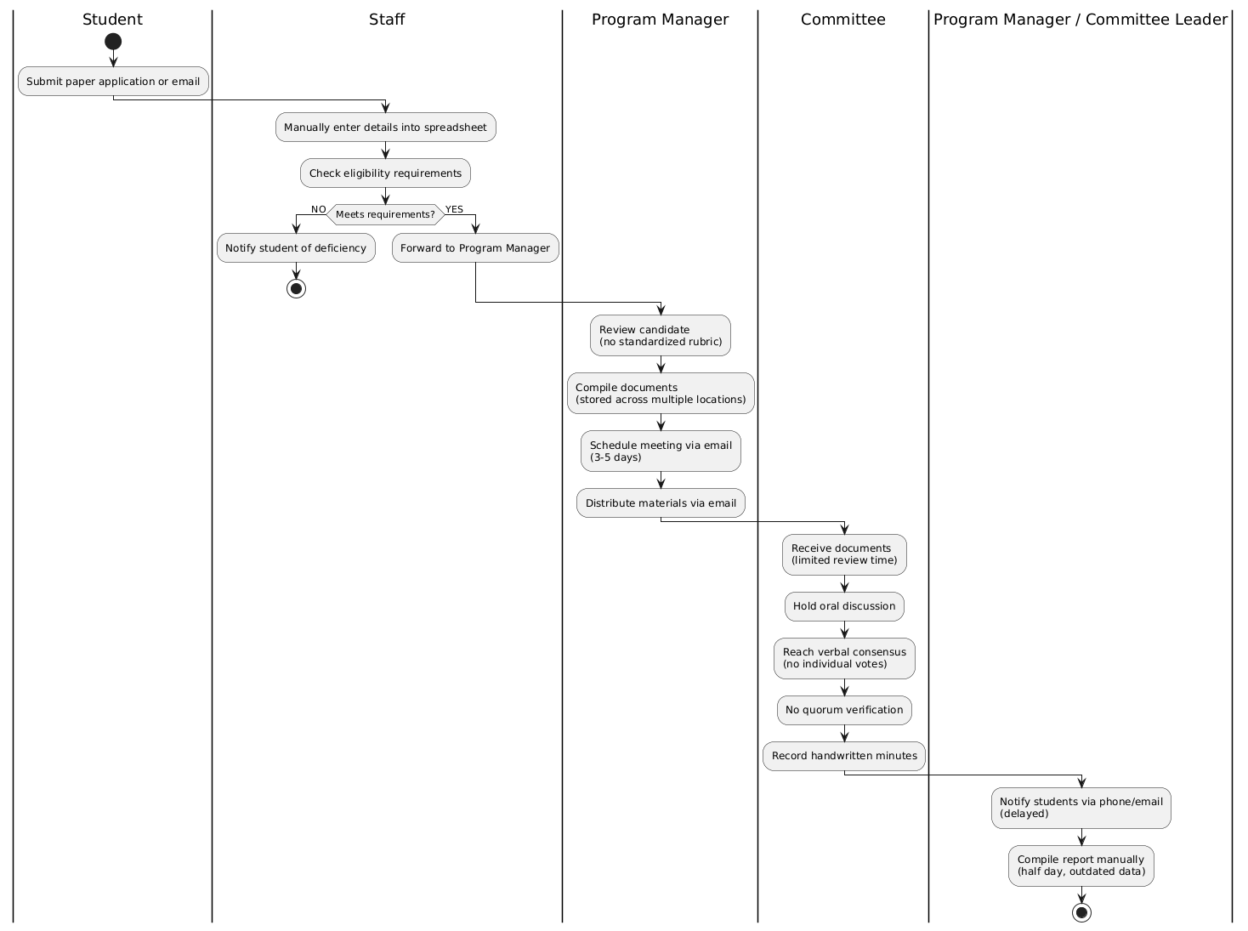
Figure 1: Modelling of the current system

Current System Workflow
Step 1: Application Submission
- Student submits paper application or email
- No centralized digital portal
Step 2: Data Entry and Eligibility Check
- Staff manually enters details into spreadsheet
- Checks eligibility requirements
- If NO → Notify student of deficiency
- If YES → Forward to Program Manager
Step 3: Program Manager Review
- Review candidate (no standardized rubric)
- Compile documents (stored across multiple locations)
- Schedule meeting via email (3–5 days)
- Distribute materials via email
Step 4: Committee Deliberation and Voting
- Receive documents (limited review time)
- Hold oral discussion
- Reach verbal consensus (no individual votes)
- No quorum verification
- Record handwritten minutes
Step 5: Notification and Reporting
- Notify students via phone/email (delayed)
- Compile report manually (half day, outdated data)

Problems of the Current System
Current candidate selection at Mastery Hub of Rwanda relies heavily on manual processes, including paper-based applications, spreadsheet tracking, physical document storage, and informal communication methods such as phone calls and emails. These practices create inefficiencies, delays, and weak coordination between staff, committee members, and applicants. The key challenges are summarized as follows:
Performance
- The manual workflow for collecting applications, reviewing candidates, and coordinating committee decisions involves multiple handovers between students, staff, program managers, and committee members, slowing the entire selection process.
- Reliance on personal spreadsheets, physical files, and email communication causes data duplication, misplaced documents, and inconsistencies in candidate evaluation.
Response Time
- Communication between students, program managers, reviewers, and committee members is slow due to manual updates, email exchanges, phone calls, and physical meetings.
- Stakeholders often receive delayed notifications about application status, meeting schedules, or final decisions.
- The lack of real-time tracking tools forces follow-ups to occur manually through phone calls or emails, increasing response times and delaying critical selection decisions.
Information
Input
- Applications and supporting documents are submitted via paper forms or email attachments without standardized formats, making consolidation and validation difficult.
- No automated data validation exists, increasing the likelihood of data entry errors, missing information, or duplicated records across different spreadsheets.
Output
- Notifications to applicants regarding application status, meeting schedules, or final decisions are shared informally through multiple channels, without tracking or confirmation of receipt.
- Selection reports are manually compiled, reducing accuracy and delaying submission to management.
Storage
- Application records, academic transcripts, evaluation scores, and committee meeting minutes are stored in scattered personal spreadsheets, physical filing cabinets, shared drives, or isolated files, with no centralized database.
- Fragmented storage increases the risk of permanent data loss, document misplacement, or incomplete records when staff transition to new roles or departments.

Economics
  - The manual system consumes significant time, effort, and staff resources to collect applications, evaluate candidates, coordinate committee meetings, and process selection decisions across multiple programs.
  - Delayed decisions result in qualified candidates accepting other opportunities, reducing the quality of selected candidates.
  - Administrative workload is high, with staff spending excessive time on data entry, document retrieval, and follow-up communications instead of strategic program development.
  - Inefficiency is especially pronounced during peak application periods, affecting overall program effectiveness and organizational reputation.
Control
  - There is no systematic mechanism for monitoring application processing time, evaluation consistency, selection rates, or adherence to selection policies.
  - Manual tracking makes it difficult to verify the accuracy of applicant data, evaluation scores, or whether selection criteria are being applied consistently.
  - The absence of digital audit trails reduces accountability across the candidate selection lifecycle.
  - No automated alerts exist to warn of incomplete applications, pending reviews, or approaching deadlines before problems materialize.
Efficiency
- The candidate selection process requires continuous manual interaction among students, program managers, reviewers, and committee members, making operations slow, cumbersome, and highly error-prone.
- Manual interventions at each stage increase the likelihood of calculation errors, misplaced documents, version control issues, and decision delays, ultimately affecting the quality and timeliness of selection outcomes.
- Duplication of efforts occurs when different staff members maintain their own spreadsheets and records without awareness of each other's work or access to consolidated data, leading to inconsistencies and redundant tasks.
- Retrieving application information often requires searching across multiple systems, resulting in significant time wastage and reduced productivity for staff.
- Without integrated digital workflows, tracking application progress and monitoring task completion becomes challenging, increasing the risk of overlooked or incomplete applications.
Service
  - Students have limited visibility over their application status, evaluation progress, and final decisions.
  - No automated alerts exist, leaving applicants dependent on periodic manual follow-ups or phone calls for critical updates.
  - Communication gaps and lack of transparency reduce trust among applicants, donors, and partner institutions, leading to dissatisfaction and reduced future applications.
- Applicants receive no timely feedback after submission, forcing them to repeatedly contact staff for basic status updates.

Proposed Solutions
The proposed solution to address the inefficiencies in current candidate selection practices is the implementation of the AI-Based Internship Candidate Selection System, a centralized, intelligent digital platform designed to automate and streamline the entire selection lifecycle, from application submission to final decision-making.
Key features and benefits of the proposed platform include:
Centralized Digital Platform: The system will serve as a unified online portal for student registration, application submission, candidate evaluation, committee deliberation, and reporting across all levels: student, reviewer, program manager, and committee.
User-Friendly Interface and Accessibility: Built with React.js for the frontend, Spring Boot (Java) for the backend, and PostgreSQL for data management, the platform will be intuitive, responsive, and mobile-accessible to reach students across different locations.
Enhanced Collaboration and Communication: Integrated discussion forums and notification tools will allow direct communication between committee members, program managers, and applicants in real time.
Automated Reporting and Notifications: The system will generate automatic application status updates, eligibility results, score breakdowns, and final decision letters to enhance transparency and decision-making efficiency.
AI-Powered Candidate Scoring and Matching: Intelligent algorithms will evaluate applicants based on academic performance, extracurricular achievements, and program-specific criteria, recommending the most suitable candidates for each opportunity.
Data Transparency and Accountability: Every activity, from application submission to final selection decision, will be logged digitally with timestamps and user identification for traceability and evaluation, promoting accountability and fairness.
Fairness Monitoring Dashboard: The system will track selection outcomes across demographic groups, alerting administrators to potential bias and supporting continuous improvement in selection practices.

System Requirements
The proposed AI-Based Internship Candidate Selection System for Mastery Hub of Rwanda must meet both functional and non-functional requirements to ensure it operates efficiently, securely, and in alignment with the organization's operational needs. Below are the key system requirements for the AI-Based Internship Candidate Selection System.

Functional Requirements
The proposed AI-Based Internship Candidate Selection System shall provide the following functional capabilities:
- REQ 1: The system shall allow students to create accounts, log in securely, and manage their profiles.
- REQ 2: The system shall enable students to submit applications with personal details, academic background, skills, and supporting documents.
- REQ 3: The system shall generate a unique reference number and allow students to track application progress in real time.
- REQ 4: The system shall send automated notifications via email and SMS at each stage of the selection process.
- REQ 5: The system shall allow Program Managers to configure programs, verify applications, view AI rankings, assign reviewers, and make final decisions.
- REQ 6: The system shall provide Reviewers with a standardized rubric to submit ratings and comments for assigned applications.
- REQ 7: The system shall provide an asynchronous discussion forum and support secure digital voting with mandatory justification.
- REQ 8: The system shall record user identity and timestamp for all actions, maintain audit logs, and provide a fairness monitoring dashboard.

Non-Functional Requirements
The system shall satisfy the following non-functional requirements to ensure effective performance and usability:
- REQ 8: Performance The system shall process AI scoring within seconds and load dashboards in under three seconds under normal load. This ensures a responsive user experience and minimizes waiting time for users.
- REQ 9: Security The platform shall use JWT and OAuth 2.0 authentication, role-based access control, and TLS encryption.
- REQ 10: Scalability The platform shall support an increasing number of students, programs, and applications.
- REQ 11: Reliability The system shall maintain a minimum uptime of 99.5% during peak application periods. This ensures the system remains available when users need it most.
- REQ 12: Usability Students shall complete applications in under ten minutes, and staff shall perform core tasks with minimal training.
- REQ 13: Maintainability The platform should use a modular architecture separating frontend (React.js), backend (Spring Boot), AI service (Python), and database (PostgreSQL) with well-documented components. This allows for easy maintenance, troubleshooting, updates, and future integrations.
- REQ 14 :Compatibility The system should be compatible with all major browsers including Google Chrome, Mozilla Firefox, Microsoft Edge, and Opera. This ensures users can access the platform from any device.
- REQ 15: Auditability The system shall maintain a tamper-evident audit log of all significant actions including logins, submissions, scores, reviews, votes, and decisions. This provides accountability and supports dispute resolution.

CHAPTER 3

REQUIREMENTS ANALYSIS AND DESIGN OF THE NEW SYSTEM

Introduction
This chapter presents the design and analysis of the proposed AI-Based Internship Candidate Selection System. It translates the requirements identified in Chapter 2 into a structured system design that serves as the blueprint for development. The chapter includes system architecture, functional and non-functional requirements, and modeling using UML diagrams such as use-case, class, sequence, and activity diagrams. The objective is to clearly illustrate how system components interact to achieve efficient candidate selection, AI-driven scoring, digital voting, and fairness reporting.
The chapter begins by outlining the analysis and design methodology adopted, followed by a discussion of the object-oriented approach used to model the system's structure and behavior. UML diagrams are presented to provide a visual representation of the system, including use-case diagrams for user interactions, class diagrams for static structure, sequence diagrams for dynamic interactions, and activity diagrams for workflow processes. The chapter also covers database design, data dictionary, and system architecture, ensuring a comprehensive understanding of how the system will be built and how its components will function together.
The requirements analysis phase identifies system actors, defines their interactions, documents system behaviors, and specifies functional and non-functional constraints. Functional requirements cover student profile management, program management, application submission, eligibility assessment, AI scoring, opportunity matching, reviewer evaluation, committee deliberation, voting, fairness reporting, and notifications. Non-functional requirements address performance, security, scalability, availability, and usability. The design phase defines the architecture, core modules, data flows, and interactions required to address the challenges identified in Chapter 2. The design emphasizes data integration, scalability, modularity, and reusability while prioritizing security, data integrity, usability, and performance. This chapter provides the engineering blueprint that makes the digital transformation of candidate selection at Mastery Hub of Rwanda technically feasible.

Analysis and Design Methodology
The system analysis and design methodology is a structured approach used to analyze and develop the AI-Based Internship Candidate Selection System. The methodology helps identify selection challenges faced by Mastery Hub of Rwanda and supports the development of an intelligent and user-friendly platform capable of managing applications, evaluating candidates, and supporting transparent selection decisions in real time.
System analysis involves examining the limitations of existing candidate selection methods at Mastery Hub of Rwanda. The analysis identifies key challenges such as manual application processing, lack of real-time tracking, subjective candidate evaluation, fragmented document storage, weak committee coordination, and the absence of affordable intelligent selection systems.
System design focuses on defining the architecture, software components, interaction processes, and database structures required to achieve the objectives of the platform. The design process considers important principles such as usability, scalability, maintainability, accuracy, and performance to ensure the system operates efficiently, reliably, and securely. By carefully addressing these principles, the system is designed to support current operational needs while remaining adaptable to future growth and technological advancements.
The system architecture includes a responsive user interface developed using React.js, backend services implemented using Spring Boot (Java), and a PostgreSQL database system for storing user information, applications, program data, AI scores, reviews, votes, and fairness reports. The platform also integrates artificial intelligence and machine learning technologies to evaluate candidates based on academic performance, skills, leadership, achievements, and program-specific criteria.
In addition, the methodology emphasizes user-centered development and continuous testing throughout the implementation process. Information collected through documentation review, observation, and interviews helps define the system requirements, workflow models, and technical design decisions. This approach ensures that the final system effectively supports fair, transparent, and efficient candidate selection for Mastery Hub of Rwanda.

Object-Oriented Methodology
Although several software engineering approaches such as the Structured Approach, Waterfall Model, and Rapid Prototyping can be used for system development, the AI-Based Internship Candidate Selection System adopts the Object-Oriented Methodology (OOM). This methodology is suitable because it supports modularity, scalability, maintainability, and reusability, which are important for intelligent web-based selection systems.
The Object-Oriented Methodology is beneficial for the development of this system because it allows system components such as users, applications, programs, AI scoring modules, voting systems, and fairness reports to be modeled as objects with specific attributes and functions. System operations including user registration, application submission, eligibility verification, AI scoring, reviewer evaluation, digital voting, and fairness reporting can be divided into separate objects, improving system organization and development efficiency. Additionally, OOM works effectively with Unified Modeling Language (UML), which helps in designing use case, class, sequence, and activity diagrams.
Under Object-Oriented Methodology, objects are instances of classes representing real-world entities. The User class stores user ID, email, password, and role with methods for login, logout, and registration. The Student class inherits from User and represents applicants with attributes such as student ID, name, phone, gender, and district, and methods for registration, application submission, and status tracking. The Application class manages submitted applications with attributes like application ID, reference number, status, and submission date, offering methods to submit, withdraw, and retrieve status. The AI Score class handles AI-generated evaluation results with attributes including score ID, overall score, rank, and confidence, and provides methods to calculate and explain scores. The Committee Vote class manages digital votes with attributes such as vote ID, decision, justification, and timestamp, and includes methods to cast and update votes. The Fairness Report class monitors selection equity using attributes like report ID, metrics, alerts, and demographic breakdowns, with methods to generate and export reports. The modular nature of Object-Oriented Methodology enables the system to be structured into independent yet interconnected components, improving maintainability and scalability.

Unified Modelling Language (UML)
Unified Modeling Language (UML) is a standardized visual modelling language used in object-oriented software engineering to model, specify, and document the structure and behavior of a system. UML enables developers and stakeholders to visualize how various parts of a system interact, simplifying the planning, communication, and implementation of complex software systems.
In this project, UML is used to model the proposed AI-Based Internship Candidate Selection System, representing selection workflows, user interactions, application processing, AI scoring processes, data structures, and decision-making operations. These models serve as blueprints that guide the development of the system and ensure alignment between functional requirements and final system behavior.
The UML diagrams used in the design of the proposed system include the following:
Use Case Diagram: Illustrates the functional requirements of the system from the users' perspective, showing how students, reviewers, program managers, and administrators interact with the platform during application submission, candidate evaluation, committee deliberation, and decision-making processes.
Class Diagram: Describes the static structure of the system by defining classes, attributes, methods, and relationships, supporting the design of user management, application processing, AI scoring, committee voting, and fairness reporting components.
Sequence Diagram: Shows the chronological sequence of interactions between users and system components during processes such as application submission, eligibility verification, AI scoring, reviewer evaluation, committee voting, and final decision generation.
Activity Diagram: Represents the workflow of activities within the system, highlighting the process flow from application submission and eligibility verification to AI scoring, committee deliberation, digital voting, and final decision notification.
Database Diagram: Models the logical database structure by identifying entities, attributes, and relationships required for storing user information, applications, program data, AI scores, reviews, votes, and fairness reports securely and efficiently.

Design of the New System
The design of the proposed AI-Based Internship Candidate Selection System makes use of UML diagrams to visually represent how users interact with the system and how different system components operate together. These diagrams translate functional requirements into clear visual models, ensuring that selection processes, application handling, AI scoring, and decision-making operations are properly defined and aligned with the needs of students, reviewers, program managers, and administrators at Mastery Hub of Rwanda. Through visual modeling, system interactions and processing workflows are clearly illustrated, reducing ambiguity and improving overall system understanding.
Based on the operational structure of the proposed system, several primary actors have been identified, representing users who interact directly with the system during candidate selection processes. These actors include students who submit applications and track their status, reviewers who evaluate candidates and cast votes, program managers who configure programs and make final decisions, and system administrators who manage users and oversee system operations. Each actor interacts with the system through role-specific interfaces, ensuring that users can access only the functionalities relevant to their responsibilities while maintaining security and accountability.
Actors
An actor represents any user or external entity that interacts with the system. In the context of the AI-Based Internship Candidate Selection System, the following actors are involved:
- Student: Submits applications, uploads supporting documents, tracks application status, and receives recommendations for suitable programs.
- Reviewer: Evaluates assigned applications using standardized rubrics, participates in committee discussions, and casts votes on candidates with mandatory justification.
- Program Manager: Creates and configures programs, sets eligibility criteria, assigns reviewers to committees, reviews AI-generated rankings, and makes final grant or deny decisions.
- System Administrator: Manages user accounts, assigns roles, views audit logs, configures system settings, and monitors overall system performance.
- AI Scoring Engine: Processes candidate data, evaluates academic performance, skills, leadership, achievements, and motivation letter quality, and generates overall scores and rankings.
Use Case Diagram
Use case diagrams are visual tools within UML that illustrate the interactions between a system and its external environment, capturing the essential business requirements for system operation. These diagrams represent a business entity or software system, its external stakeholders (known as actors), and a set of tasks (use cases) that users are expected or authorized to perform when interacting with the system. They are particularly useful for defining the system's functionality from the viewpoint of its users.
By providing a clear, concise overview of how users interact with the system, use case diagrams help both developers and stakeholders better understand the system requirements. Additionally, they serve as an effective communication tool, allowing project teams to visually map out the roles and actions involved in achieving system goals.
The symbols below are used in Use Case Diagram
  System | System  The rectangular boundary represents the system. Use cases are placed within it, while actors are positioned outside.
Use Case
An oval shape denotes a use case. Use cases depict the system's functionality and the actor's ultimate objective. Use cases should be positioned within the system.
 | Actor  When an actor engages with the system, it initiates a use case. Actors should be positioned outside the system.
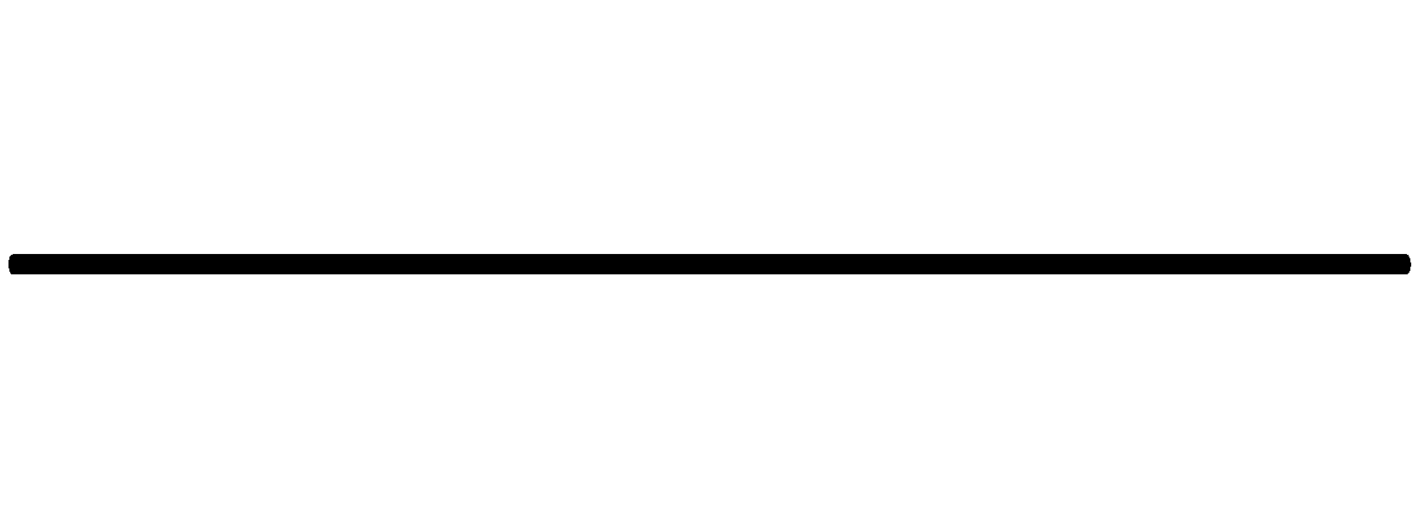 | Relationships  A line signifies a relationship between an actor and a use case, or between two use cases. An extension shows that one use case may incorporate the behavior of another use case. An inclusion represents one use case utilizing the functionality of another use case.
 | Extend  Relationship: This indicates that a use case can expand the behavior of another use case under certain conditions. Use Case B extends Use Case A when Use Case B is a variant of Use Case A. The relationship is depicted with a dashed arrow and a «extend» label.
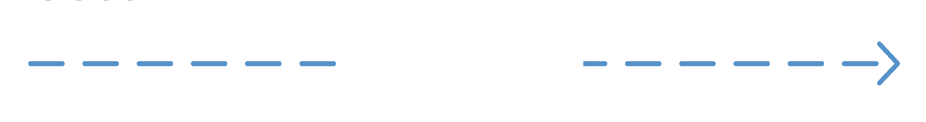 | Include  Relationship: Use Case A includes Use Case B when Use Case B is a shared behavior that Use Case A requires. Use Case B exists as a separate Use Case because other use cases utilize it. The include relationship is depicted with a dashed arrow and a «include» label.
Association
Relationship: The association relationship indicates a communication path between an actor and a use case. It emphasizes that an actor engages with a particular use case, showing the participation of actors in the system's functions. This relationship helps identify the external entities that engage with the system's processes. It is depicted by a line connecting an actor and a use case.

Use Case Diagram of the System
The use case diagram illustrates interactions between four actors (Student, Reviewer, Program Manager, Admin) and key system functions including application submission, eligibility verification, AI scoring, voting, and fairness reporting.
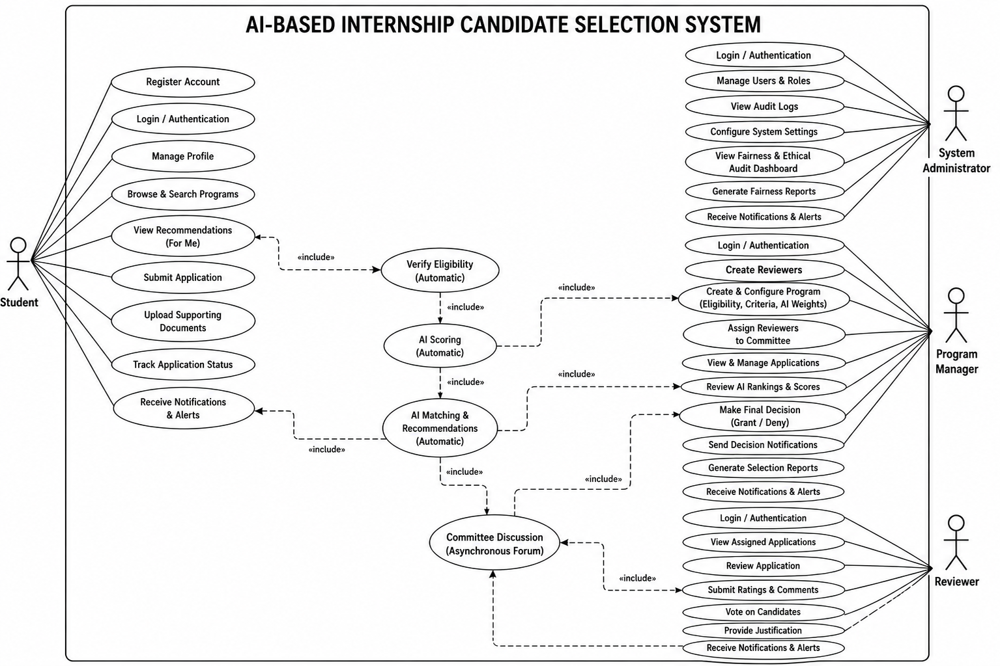
Figure 2: Ai-Based Internship Selection System Use Case Diagram
Use Case Description
A Use Case description specifies what a use case accomplishes, and what it requires to be properly performed. Each use case is documented using the following structure:
- Name: A unique identifier for the use case
- Description: A brief explanation of what the system aims to accomplish through this use case
- Actor: The primary participant(s) involved in the use case
- Precondition: The system state required before the use case may start
- Post-condition: The system state after the use case is successfully completed
- Normal Flow: The primary sequence of steps describing the standard scenario
- Alternative Flow: Variations or exception conditions that could occur during execution
Use Case Description for Student
Element | Description
Name | Submit Application
Actor | Student
Description | Allows student to apply for an internship program
Precondition | Student must be logged in and have a complete profile
Post-condition | Application is stored with status "Submitted" and a unique reference number is generated
Normal Flow | 1. Student logs into the system.  2. Navigates to "Find Programs".  3. Selects a program.  4. Completes the wizard-based form with application details.  5. Uploads supporting evidence documents.  6. Submits the form.  7. System validates the data and confirms submission, providing a unique reference number.
Alternative Flow | If required fields are missing or documents are invalid, the system prompts the student to correct the errors before submission.
Table 1: Use Case Description for Student
Use Case Description for Student - Track Status
Element | Description
Name | Track Application Status
Actor | Student
Description | Allows student to monitor the progress and status of submitted applications
Precondition | Student must have submitted at least one application
Post-condition | Student can view updated application status in real time
Normal Flow | 1. Student logs into dashboard.  2. Selects "My Applications".  3. Views list of submitted applications.  4. Opens application details.  5. System displays current status (Submitted, Eligibility Passed, Under Review, Committee Deliberation, Granted, Denied).
Alternative Flow | System shows message if no applications exist.
Table 2: Use Case Description for Student - Track Status
Use Case Description for Program Manager - Create Program
Element | Description
Name | Create and Configure Program
Actor | Program Manager
Description | Allows program manager to create new internship opportunities with eligibility criteria and AI scoring weights
Precondition | Program manager must be authenticated
Post-condition | Program is stored in database and visible to students
Normal Flow | 1. Program Manager logs in.  2. Selects "Create Program".  3. Enters program details (title, description, deadline, type).  4. Configures eligibility criteria (minimum GPA, required field of study, etc.).  5. Sets AI scoring weights for different criteria.  6. Publishes the program.  7. System confirms program is live.
Alternative Flow | If required fields are missing, system prevents publication and alerts the manager.
Table 3: Use Case Description for Program Manager - Create Program
Use Case Description for Program Manager - Grant/Deny Decision
Element | Description
Name | Grant or Deny Internship
Actor | Program Manager
Description | Allows program manager to make the final decision to grant or deny an internship to a candidate
Precondition | Committee voting has been completed and voting results are available
Post-condition | Final decision is recorded and student is notified
Normal Flow | 1. Program Manager logs in.  2. Navigates to program dashboard.  3. Reviews committee votes and recommendations  4. Selects a candidate.  5. Clicks "Grant" or "Deny".  6. Adds decision justification.  7. Confirms the decision. 8. System records final decision.  9. System triggers notification to student.
Alternative Flow | If Program Manager attempts to grant more candidates than available slots, system displays warning and prevents action.
Table 4: Use Case Description for Program Manager - Grant/Deny Decision
Use Case Description for Reviewer
Element | Description
Name | Review Assigned Application
Actor | Reviewer
Normal Flow | 1. Reviewer logs in.  2. Views assigned applications queue.  3. Selects an application.  4. Reviews student profile, AI scores, and uploaded documents.  5. Provides ratings using structured rubrics.  6. Adds mandatory comments.  7. Submits the review.  8. System confirms submission.
Alternative Flow | If reviewer attempts to submit without completing all required ratings, system prompts to complete missing fields.
Table 5: Use Case Description for Reviewer
Use Case Description for Reviewer - Cast Vote
Element | Description
Name | Cast Vote
Actor | Reviewer
Description | Allows reviewer (as committee member) to cast vote on candidate selection
Precondition | Reviewer must be logged in, assigned to committee, and voting must be open
Post-condition | Vote is recorded with timestamp and justification
Normal Flow | 1. Reviewer logs in.  2. Navigates to "Committee Workspace".  3. Selects a candidate for voting.  4. Reviews candidate information, AI scores, and discussion.  5. Selects vote option (Approve/Reject).  6. Adds mandatory justification comment.  7. Submits the vote.  8. System records the vote and updates progress tracker.
Alternative Flow | If a reviewer attempts to vote twice on the same candidate, the system rejects the second attempt with an error message.
Table 6: Use Case Description for Reviewer - Cast Vote
Use Case Description for System Administrator
Element | Description
Name | Manage Users
Actor | System Administrator
Description | Allows administrator to create, modify, and deactivate user accounts
Normal Flow | 1. Administrator logs in.  2. Navigates to "User Management".  3. Views list of all users.  4. Selects a user to edit.  5. Modifies role (Student, Reviewer, Program Manager, Admin).  6. Saves changes.  7. System confirms update.
Alternative Flow | If administrator attempts to delete own account, system prevents action.
Table 7: Use Case Description for System Administrator

Class Diagrams
The Class Diagram of the AI-Based Internship Candidate Selection System presents the main structural components that support user management, application processing, AI scoring, committee voting, and fairness reporting. It defines key classes such as User, Student, Reviewer, ProgramManager, Administrator, Program, Application, AIScore, Review, CommitteeVote, FinalDecision, Notification, FairnessReport, and AuditLog, and illustrates how they interact through associations and relationships. These classes work together to capture student applications, process candidate data, evaluate qualifications through AI-driven scoring, facilitate committee discussion and voting, generate final selection decisions, and maintain comprehensive system records.
The diagram also shows how core classes such as Application, AIScore, Review, and CommitteeVote interact to support the complete candidate selection lifecycle. It reflects the system's object-oriented design principles and provides a clear visual representation of the static structure of the platform

Class Diagram of the AI-Based Internship Candidate Selection System
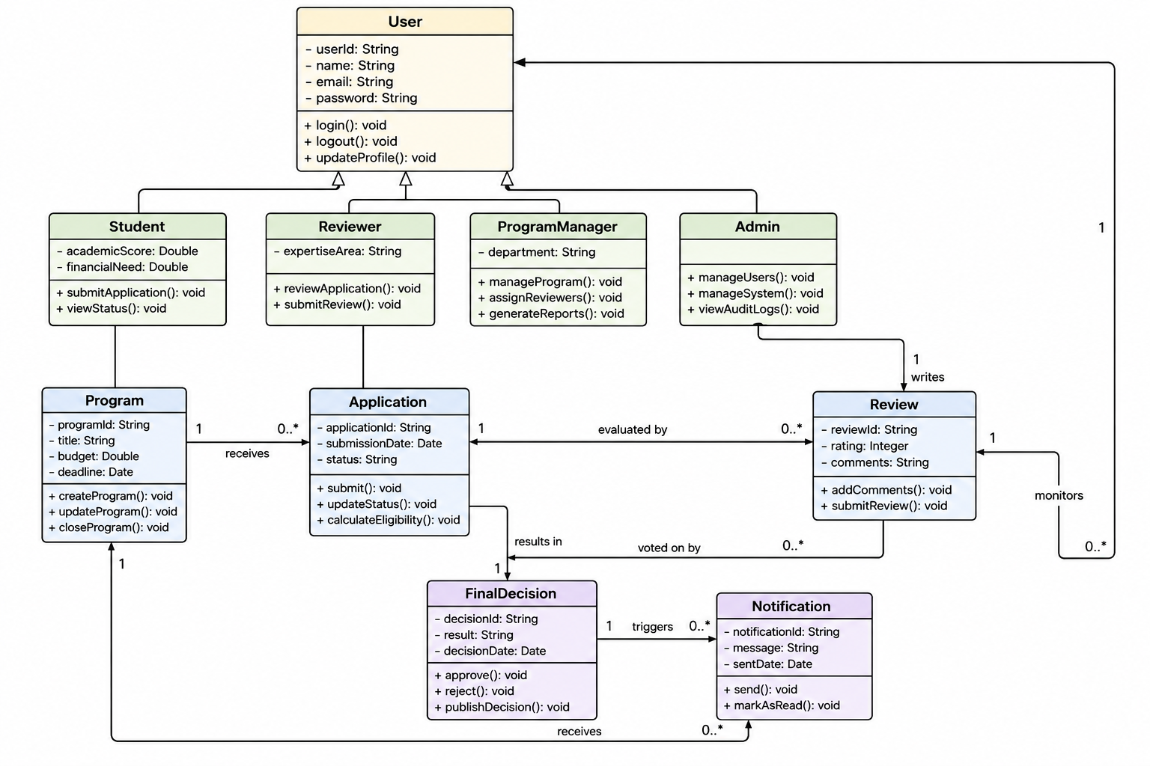
Figure 3: Class Diagram

Sequence Diagrams
A sequence diagram is a type of interaction chart that depicts objects as lifelines running down the page, with messages rendered as bolts from the source lifeline to the target lifeline, representing their interactions through time. Object interactions are arranged in temporal sequence in a sequence diagram.
In UML, the stages required to perform an operation are described in sequence diagrams, which are interaction diagrams. They show how things interact when operating within a cooperative system. Sequence Diagrams are time-focused and use the vertical axis of the diagram to indicate time, what messages are received when, and how the interaction is organized graphically.
The notations and their definitions that are used in sequence diagram:
Term and Definition | Symbol
Actor:  - Could be a person or external system that interacts with but is not part of the system  - Participates in interactions by sending and/or receiving messages  - Positioned at the top of the diagram | 
Object Lifeline:  - Represents an object that participates in a sequence by sending and/or receiving messages  - Shows the lifespan of the object during the interaction  - Placed vertically in the diagram with object name at top | 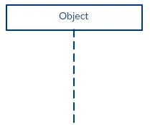
Table 8: The notations and their definitions

Sequence Diagram - Student Application Submission
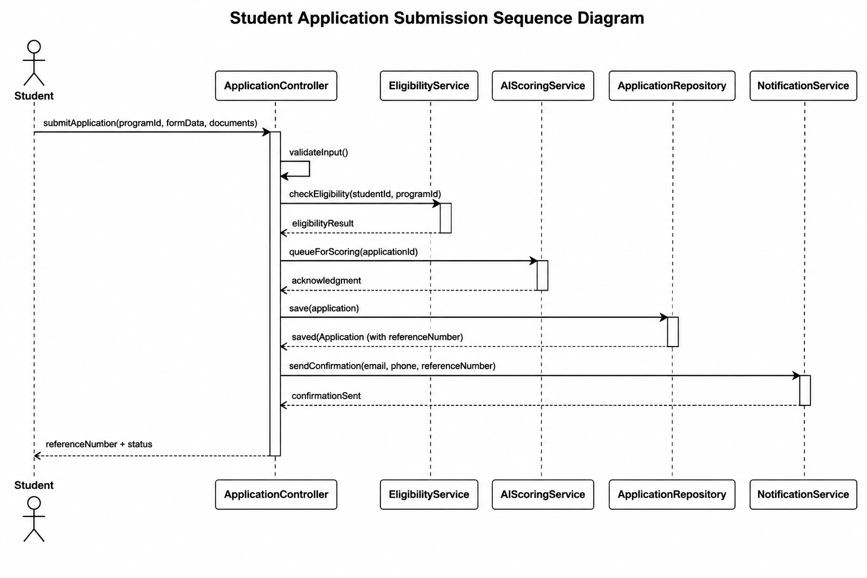
Figure 4: Sequence Diagram - Student Application Submission
Sequence Diagram - AI Scoring
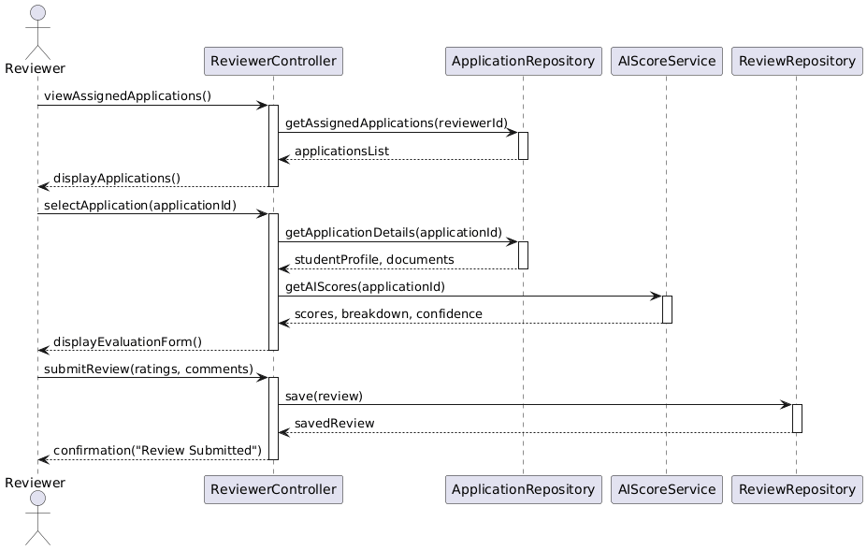
Figure 5: Sequence Diagram - AI Scoring

Sequence Diagram : Committee Member Voting
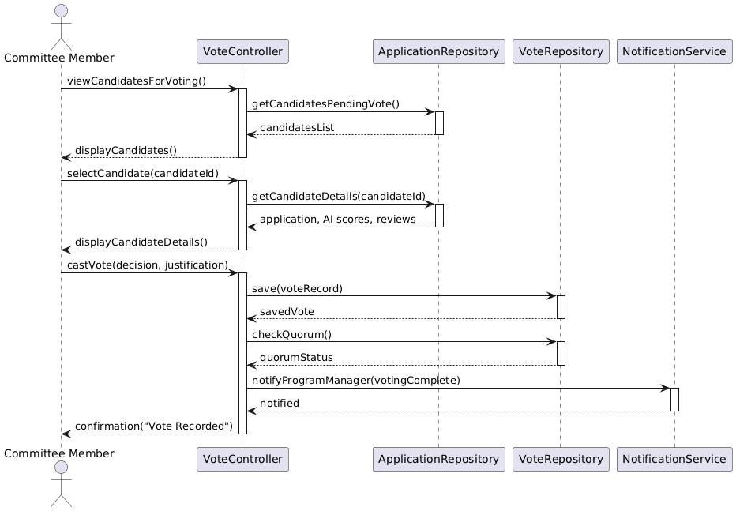
Figure 6: Sequence Diagram : Committee Member Voting
Sequence Diagram : Program Manager Final Decision
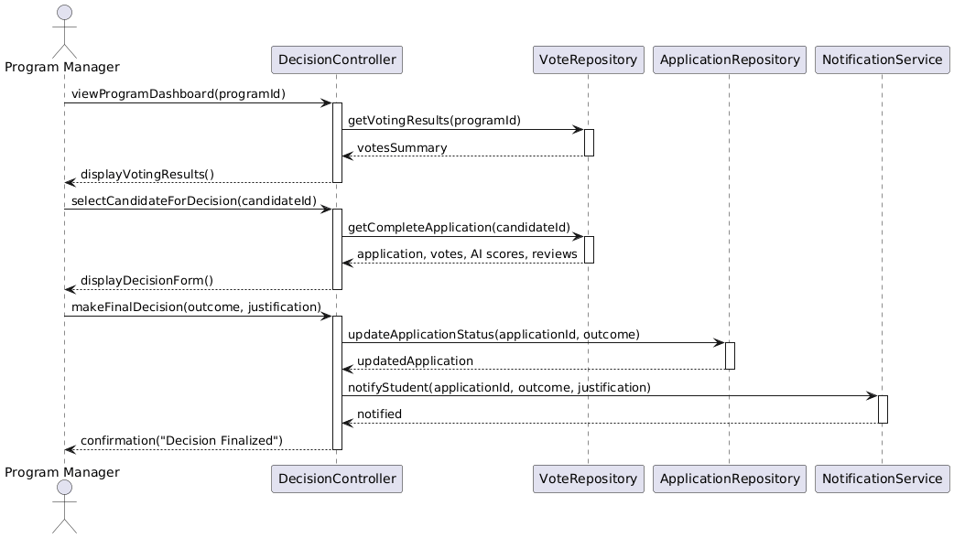
Figure 7: Sequence Diagram : Program Manager Final Decision

Activity Diagrams
An activity diagram is a type of UML diagram used to represent the workflow of a system by illustrating the sequence of activities and decision points. It shows how different operations are performed step-by-step and how the system responds to various conditions. Activity diagrams are useful for modeling the dynamic behavior of a system and understanding the overall process flow.
In this project, the activity diagram describes how the AI-Based Internship Candidate Selection System operates to process applications, evaluate candidates, and produce final selection outcomes. It outlines the flow of actions from student registration to final decision notification.
Full System Activity Diagram
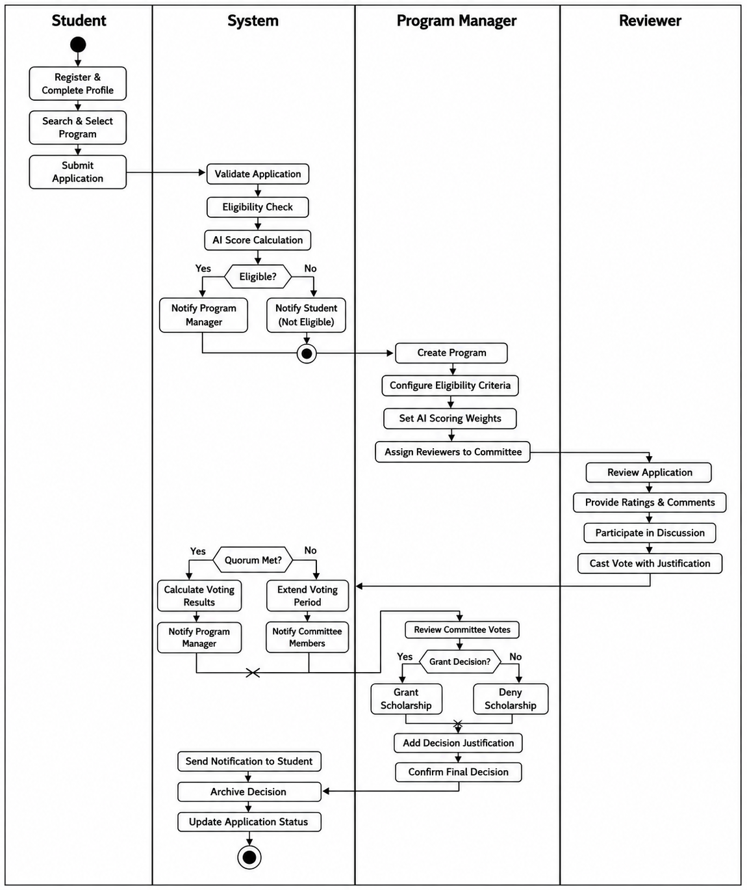
Figure 8: Full System Activity Diagram

Database Diagrams
A database schema diagram is a structural model that shows how data is organized within a system. It defines the tables, their attributes, and the relationships between them. This diagram is essential for understanding how information is stored, accessed, and maintained in a database-driven application (Elmasri, R., & Navathe, S. B., 2016).
In the AI-Based Internship Candidate Selection System, the database schema diagram was used to model how student profiles, applications, AI scores, reviews, votes, notifications, and fairness reports are stored and linked within the PostgreSQL database. This ensures data consistency, integrity, and efficient retrieval for candidate selection operations at Mastery Hub of Rwanda.
Symbols for Database Diagram
Description | Symbol
An entity is an object or concept about which you want to store information. | 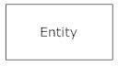
Cardinality specifies how many instances of an entity relate to one instance of another entity. While cardinality specifies the occurrences of a relationship. | |———>| |<———|
Connecting line: One to one solid line that connect attributes to show the relationships of entities in the diagram.
Attribute is a piece of information which determines the properties of a field or tag in a database or a string of characters in a display. | 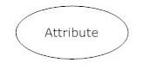
Relationships are associations between or among entities. | 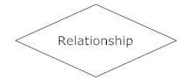
Table 9: Symbols for Database Diagram
Database Schema Diagram
The Database Schema Diagram illustrates the logical structure of the PostgreSQL database used by the AI-Based Internship Candidate Selection System. It defines the tables, their attributes, primary keys, foreign keys, and the relationships between them. The schema is designed around core entities such as users, students, applications, programs, AI scores, reviews, votes, committee discussions, final decisions, notifications, fairness reports, and audit logs. This structure ensures data integrity, supports efficient retrieval, and enables comprehensive tracking of all activities throughout the candidate selection lifecycle.
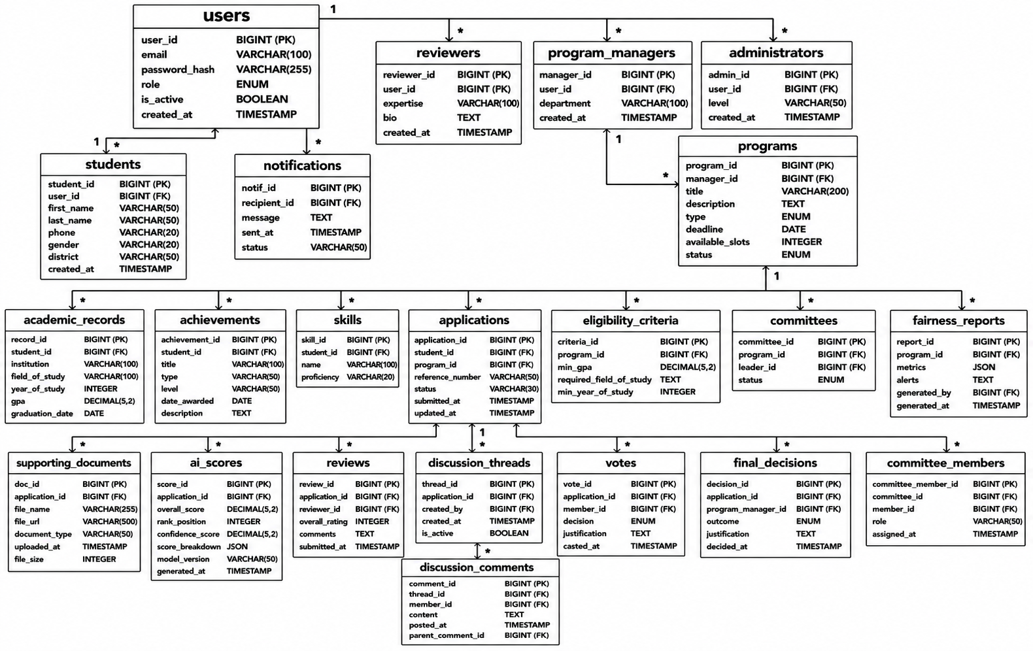
Figure 9: Database Schema Diagram

Data Dictionary
A data dictionary is a structured description of all data elements used within a system. It defines the meaning, type, format, and purpose of each data element, ensuring consistency and clarity in system design and implementation. In this project, the data dictionary describes the data generated, processed, and stored by the AI-Based Internship Candidate Selection System.
The data is mainly handled by the system through the PostgreSQL database, which stores student profiles, applications, AI scores, reviews, votes, notifications, and fairness reports for candidate selection operations at Mastery Hub of Rwanda.
Data Dictionary - students Table
Field name | Data Type | Constraint | Description
student_id | BIGSERIAL | PK, NOT NULL | Auto-increment, Unique identifier
user_id | BIGINT | FK, NOT NULL | Reference to users table
first_name | VARCHAR(50) | NOT NULL | Student's first name
last_name | VARCHAR(50) | NOT NULL | Student's last name
Email | VARCHAR(100) | NOT NULL, UNIQUE | Contact email
Phone | VARCHAR(20) | NOT NULL | Mobile number for SMS
gender | VARCHAR(20) | NULL | For fairness reporting
district | VARCHAR(50) | NULL | Geographic origin
created_at | TIMESTAMP | NOT NULL | Profile creation timestamp
Table 10: Data Dictionary - students Table
Data Dictionary - applications Table
Field Name | Data Type | Constraint | Description
application_id | BIGSERIAL | PK, NOT NULL | Auto-incrementing identifier
student_id | BIGINT | FK, NOT NULL | Reference to students table
program_id | BIGINT | FK, NOT NULL | Reference to programs table
reference_number | VARCHAR(50) | NOT NULL,UNIQUE | Unique tracking number
status | VARCHAR(30) | NOT NULLL | Submitted, Under Review, Granted, Denied
submitted_at | TIMESTAMP | NOT NULL | Submission timestamp
Table 11:Data Dictionary - applications Table
Data Dictionary - ai_scores Table
Field Name | Data Type | Constraint | Description
vote_id | BIGSERIAL | PK, NOT NULL | Auto-incrementing identifier
application_id | BIGINT | FK, NOT NULL | Reference to applications table
member_id | BIGINT | FK, NOT NULL | Reference to users table (committee member)
decision | VARCHAR(20) | NOT NULL | Approve, Reject
justification | TEXT | NOT NULLL | Mandatory comment explaining the vote
casted_at | TIMESTAMP | NOT NULL | Timestamp of vote submission
Table 12: Data Dictionary - ai_scores Table
Data Dictionary - final_decisions Table
Field Name | Data Type | Constraint | Description
decision_id | BIGSERIAL | PK, NOT NULL | Auto-incrementing identifier
application_id | BIGINT | FK, NOT NULL | Reference to applications table
program_manager_id | BIGINT | FK, NOT NULL | Reference to users table
outcome | VARCHAR(20) | NOT NULL | Granted or Denied
justification | TEXT | NOT NULLL | Explanation for final decision
decided_at | TIMESTAMP | NOT NULL | Timestamp of final decision
Table 13: Data Dictionary - final_decisions Table

System Architecture Design
The system is built on a layered architecture that provides clear separation of concerns, independent scalability, and maintainability. The architecture consists of five layers: Presentation Layer, Application Layer, AI Service Layer, Data Access Layer, and Data Storage Layer.
System Architecture Diagram
The System Architecture Diagram illustrates the layered structure of the AI-Based Scholarship and Internship Candidate Selection System, organized into five main layers: Presentation, Application, AI Service, Data Access, and Data Storage.
The Presentation Layer provides user interfaces for students, reviewers, program managers, and administrators. The Application Layer handles business logic and REST APIs using Spring Boot. The AI Service Layer provides intelligent scoring, eligibility verification, matching, and fairness monitoring using Python. The Data Access Layer manages database operations, while the Data Storage Layer stores data in PostgreSQL and documents in cloud storage. The system also integrates with External Services including Twilio SMS, Gmail SMTP, and Google OAuth 2.0.
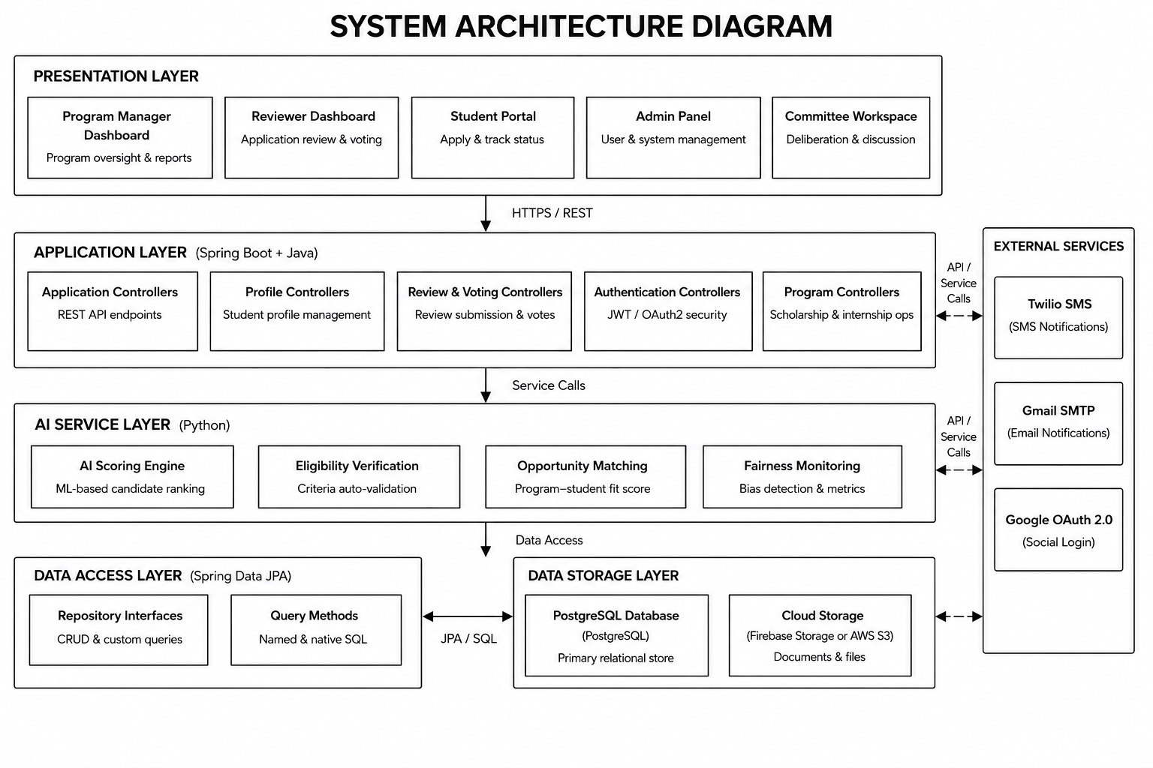
Figure 10: System Architecture Diagram

CHAPTER 4

IMPLEMENTATION OF THE NEW SYSTEM

Introduction
This chapter presents the implementation and testing of the AI-Based Internship Candidate Selection System, focusing on how the proposed system was translated from design into a fully functional web-based prototype. It provides a detailed account of the technologies used, system architecture realization, module implementation, and the testing strategies applied to ensure reliability, usability, security, and performance. The chapter bridges the gap between the conceptual design discussed in the previous chapter and the operational system developed to address the identified candidate selection challenges at Mastery Hub of Rwanda.
The implementation phase emphasizes the practical realization of core system components, including user authentication and role management, student profile creation, application submission and tracking, automated eligibility verification, AI-driven candidate scoring and ranking, intelligent opportunity matching, reviewer evaluation with standardized rubrics, asynchronous committee discussion forums, digital voting with mandatory justification, final decision granting or denial, fairness monitoring dashboards, and automated email and SMS notifications. Each module was implemented in alignment with the system requirements and objectives defined earlier, ensuring consistency with the proposed architecture and adherence to best practices in modern web application development.
In addition to system implementation, this chapter outlines the comprehensive testing and validation processes conducted to verify that the AI-Based Internship Candidate Selection System meets functional and non-functional requirements. Various testing techniques including unit testing, integration testing, system testing, and user acceptance testing were employed to confirm correctness, performance efficiency, security compliance, and overall user satisfaction. The outcomes of these testing activities demonstrate the system's readiness for deployment and its ability to support efficient, transparent, and intelligent candidate selection at Mastery Hub of Rwanda.

Technologies Used
The AI-Based Internship Candidate Selection System was developed using a set of technologies chosen for their suitability for web-based enterprise applications, their support for secure and scalable architecture, and their alignment with current industry practice.

Frontend
React.js: The user interface was built using React.js, a widely adopted JavaScript library for building interactive user interfaces. React's component-based architecture supported the development of reusable modules for student registration, application submission, dashboards, discussion forums, and voting interfaces.
CSS3 with Bootstrap Framework: Styling and responsive design were implemented using CSS3 in conjunction with Bootstrap. This approach enabled consistent, responsive layouts across different screen sizes and devices.
JavaScript (ES6+): Modern JavaScript was used for client-side interactivity, including form validations, dynamic updates, real-time notification handling, and asynchronous API calls.
Axios: This promise-based HTTP client was used to make asynchronous requests from the frontend to the backend REST APIs for submitting applications, fetching AI rankings, and retrieving voting results.
Chart.js: For data visualization, Chart.js was integrated to create interactive charts within the analytics dashboard for visualizing application trends, selection rates, and fairness metrics.
Visual Studio Code: VS Code served as the primary IDE for frontend development.

Backend
Spring Boot (Java 21 LTS): The backend was implemented using Spring Boot for building production-ready RESTful APIs. It handled authentication, profile management, application processing, AI score integration, committee voting, and report generation.
PostgreSQL 16: PostgreSQL was selected as the relational database management system for storing users, students, applications, programs, AI scores, reviews, votes, notifications, and fairness reports.
Spring Data JPA (Hibernate): This ORM tool simplified database interactions by allowing the backend to communicate with PostgreSQL using Java objects rather than raw SQL queries.
IntelliJ IDEA: IntelliJ IDEA served as the primary IDE for backend development.
Postman: Postman was used to design, test, and document all REST API endpoints.
Git & GitHub: Git and GitHub were used for version control and collaborative development.
AI and Analytics
Python 3.11: Python was selected for developing the AI service layer due to its extensive libraries for data science and machine learning. It was used to implement eligibility verification, candidate scoring algorithms, opportunity matching, and fairness monitoring.
Scikit-learn: This open-source machine learning library was used to implement AI scoring and ranking algorithms, providing tools for data preprocessing, feature scaling, and weighted scoring calculations.
Pandas: Pandas was employed for data manipulation and fairness report generation.
NumPy: NumPy was used for numerical operations required for score calculations.
External Integrations
Twilio API: Twilio's programmable SMS API was integrated to send automated text message notifications to students.
Gmail SMTP: Google's Gmail SMTP server was used to send formal email communications.
JWT and Google OAuth 2.0: JWT was used for stateless authentication, while Google OAuth 2.0 provided secure social authentication options.

Presentation of the New System
Landing Page (Homepage)
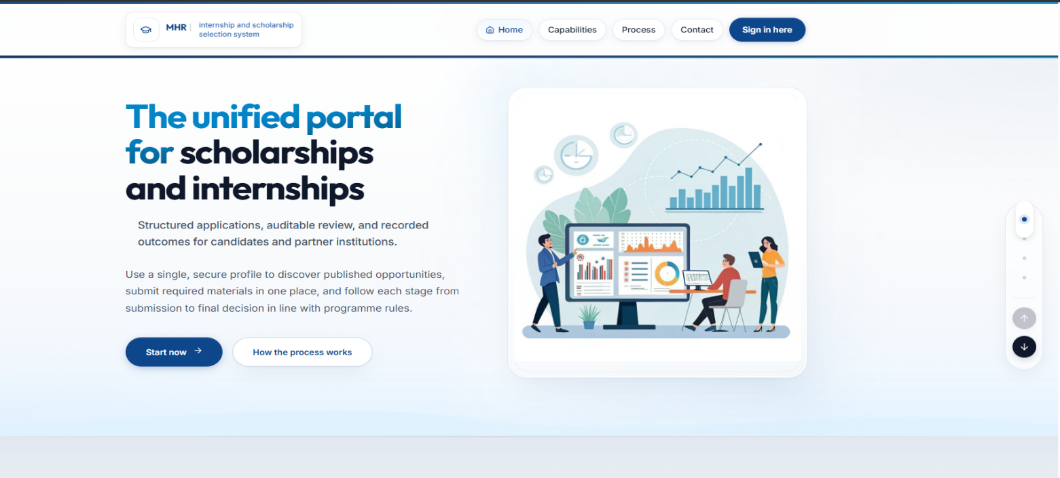
Figure 11: Landing page
The Landing Page serves as the system entry point featuring the headline "The unified portal for internships." It includes a brief description of the platform's purpose, two call-to-action buttons ("Start now" and "How the process works"), a navigation bar with "Home," "Capabilities," "Process," and "Contact" links, plus a "Sign in here" link for returning users. The page also features a "How the system works" section that explains the step-by-step application, review, and decision workflow to first-time visitors, helping them understand the selection process before they begin. Additionally, a "Companies/Partners" section displays the logos and names of organizations collaborating with Mastery Hub of Rwanda to provide internship opportunities, building trust and credibility with applicants. The footer displays "MHR | internship selection system" as the organization's branding. This page welcomes all users and provides clear pathways for both new and returning visitors to access the system's features.
Login Page
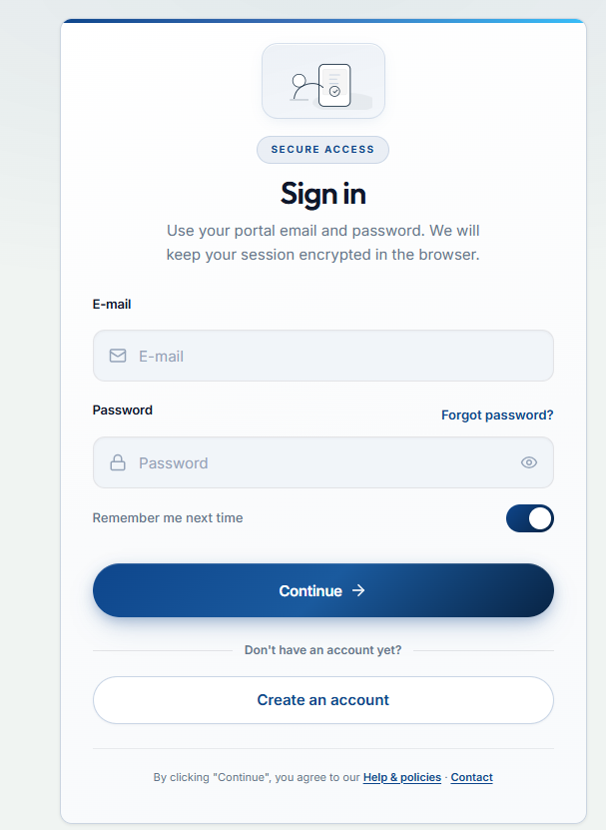
Figure 12: Login Page

The Login Page displays "SECURE ACCESS" with fields for E-mail and Password, a "Remember me next time" checkbox, a "Continue →" button, and a "Create an account" link for new users. Footer links include "Help & Policies" and "Contact" for user support.
This page provides secure authentication for all user roles using JWT tokens and role-based access control. Upon successful login, students, program managers, reviewers, and administrators are redirected to their respective dashboards.
Student Registration
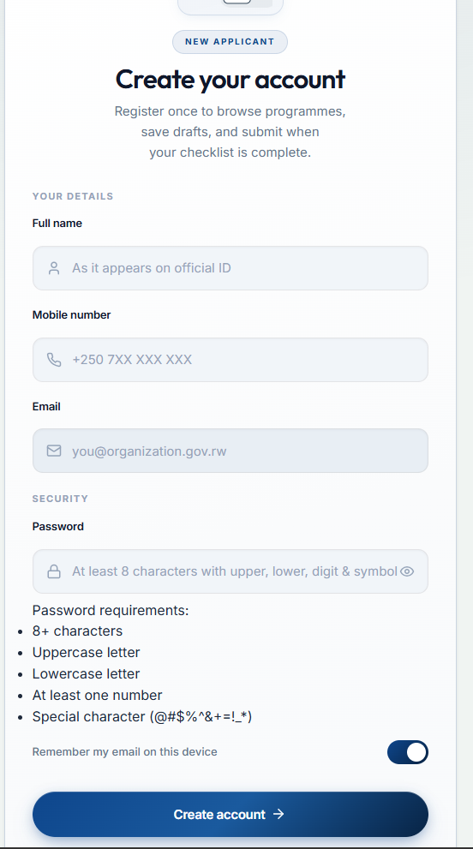
Figure 13: Registration page
The Registration Page displays "NEW APPLICANT" and "Create your account" with fields for Full name (as on official ID), Mobile number (+250 format), and Email, plus a Password field with security requirements (8+ characters, uppercase, lowercase, number, special character) and a "Remember my email on this device" checkbox. New students create their account by providing these details, and upon submission, the system validates all fields, creates the student account.

Student Dashboard
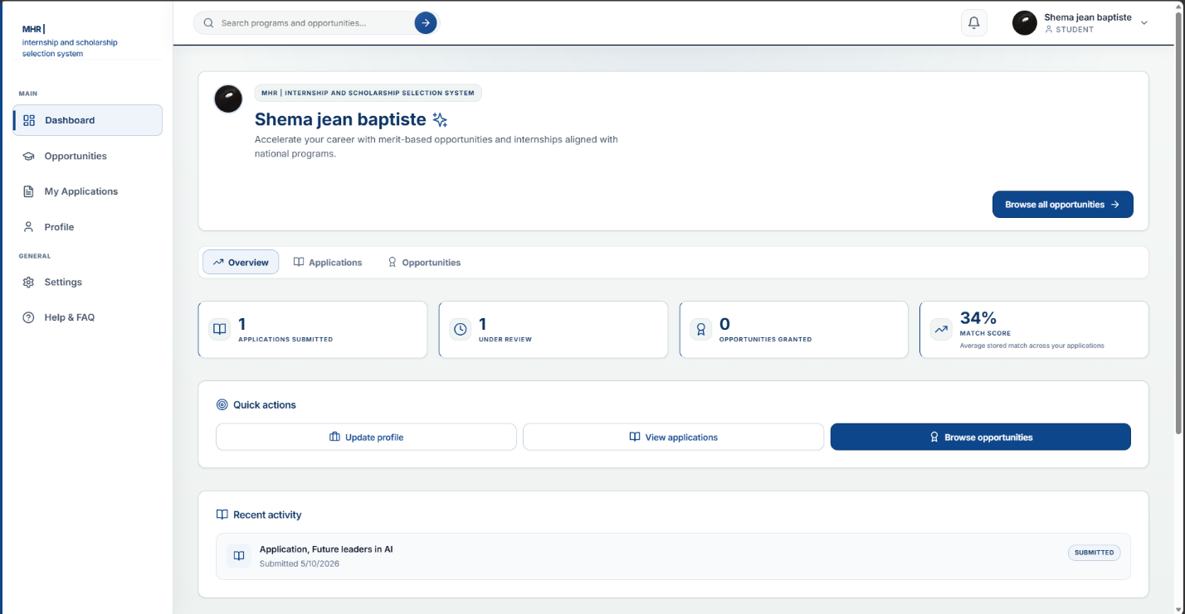
Figure 14: Student dashboard
The Student Dashboard welcomes the student by name and displays key overview cards showing the number of applications submitted and the average match score. Quick action buttons include "Browse all opportunities," "Update profile," and "View applications," while the recent activity section shows the latest application submissions with dates and statuses. A sidebar provides navigation to Opportunities, My Applications, Profile, Settings, and Help & FAQ. The dashboard also displays a match score card showing the average stored match across all submitted applications, helping students understand how well their profile aligns with available opportunities.
This dashboard gives students real-time visibility into their application activity and progress. Students can track submitted applications, view their AI-generated match scores, access recommended opportunities, and quickly update their profile information all from one central location. The dashboard serves as the student's command center, providing a complete overview of their journey from application submission to final decision, eliminating the uncertainty of manual tracking and keeping students informed at every stage.

Program Discovery and Search Interface
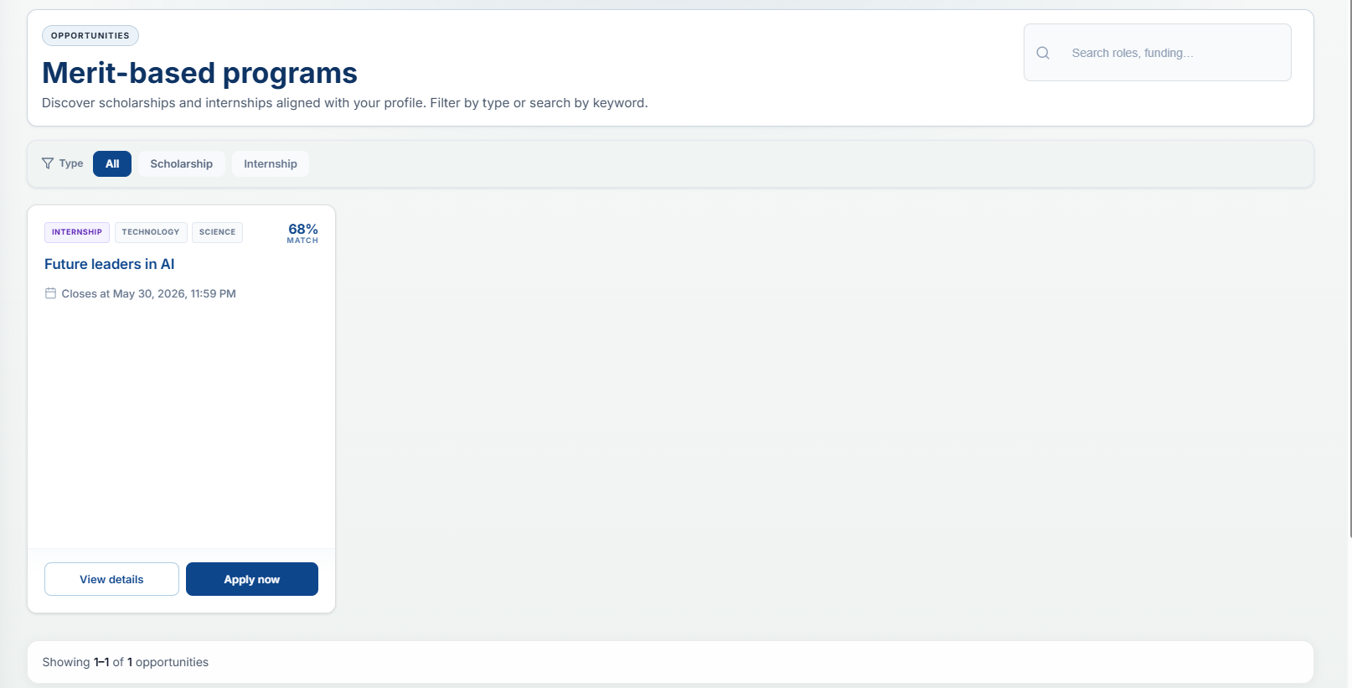
Figure 15: Program Discovery and Search Interface
Students can browse and search for available internships using keywords and filters. Filter options include program type (All, Internship) and quick filter buttons for categories like Technology and Science. Each opportunity card displays the program type, title, deadline, AI-generated match percentage, and action buttons to "View details" or "Apply now."
This interface helps students identify opportunities that best match their profile and qualifications. The AI-generated match percentage is calculated based on the student's academic records, achievements, skills, and program requirements, allowing students to prioritize applications where they have the highest chance of success. Students can click "View details" to read full program descriptions, eligibility criteria, and required documents before deciding to apply. The search and filter functionality saves time by narrowing down relevant opportunities, and the interface shows how many opportunities match the current search criteria, ensuring students never miss a deadline or suitable program.

Application Submission Wizard (Step 1 - Your Profile)
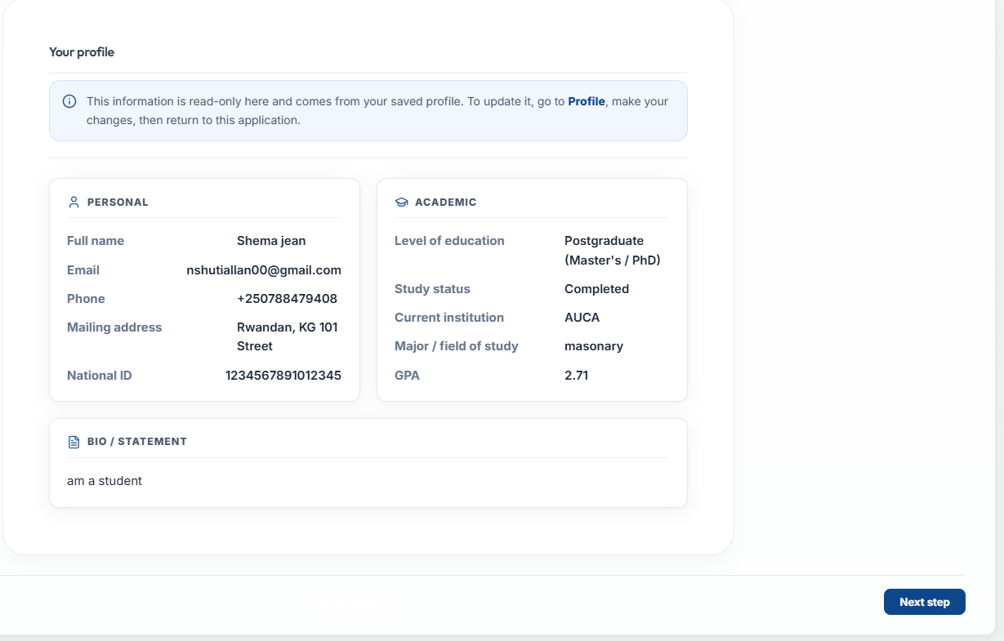
Figure 16: Application Submission Wizard (Step 1 - Your Profile)
Step 1 displays the student's read-only profile information including personal details (full name, email, phone, address, national ID), academic background (education level, study status, institution, major, GPA), and personal statement. Students cannot edit their information directly in this step, ensuring data consistency across all applications.
This design prevents students from submitting inconsistent information for different applications and encourages them to maintain an accurate, up-to-date profile. By displaying profile data in a read-only format, the system ensures that every application is based on the same verified student information, reducing errors and fraudulent submissions. Students who notice outdated information can navigate to their Profile, make corrections once, and return to the application where the updated information will automatically appear. This step also allows students to review their qualifications before committing to the application, helping them confirm they meet the eligibility requirements before proceeding to document upload.
Application Submission Wizard (Step 2 - Documents)
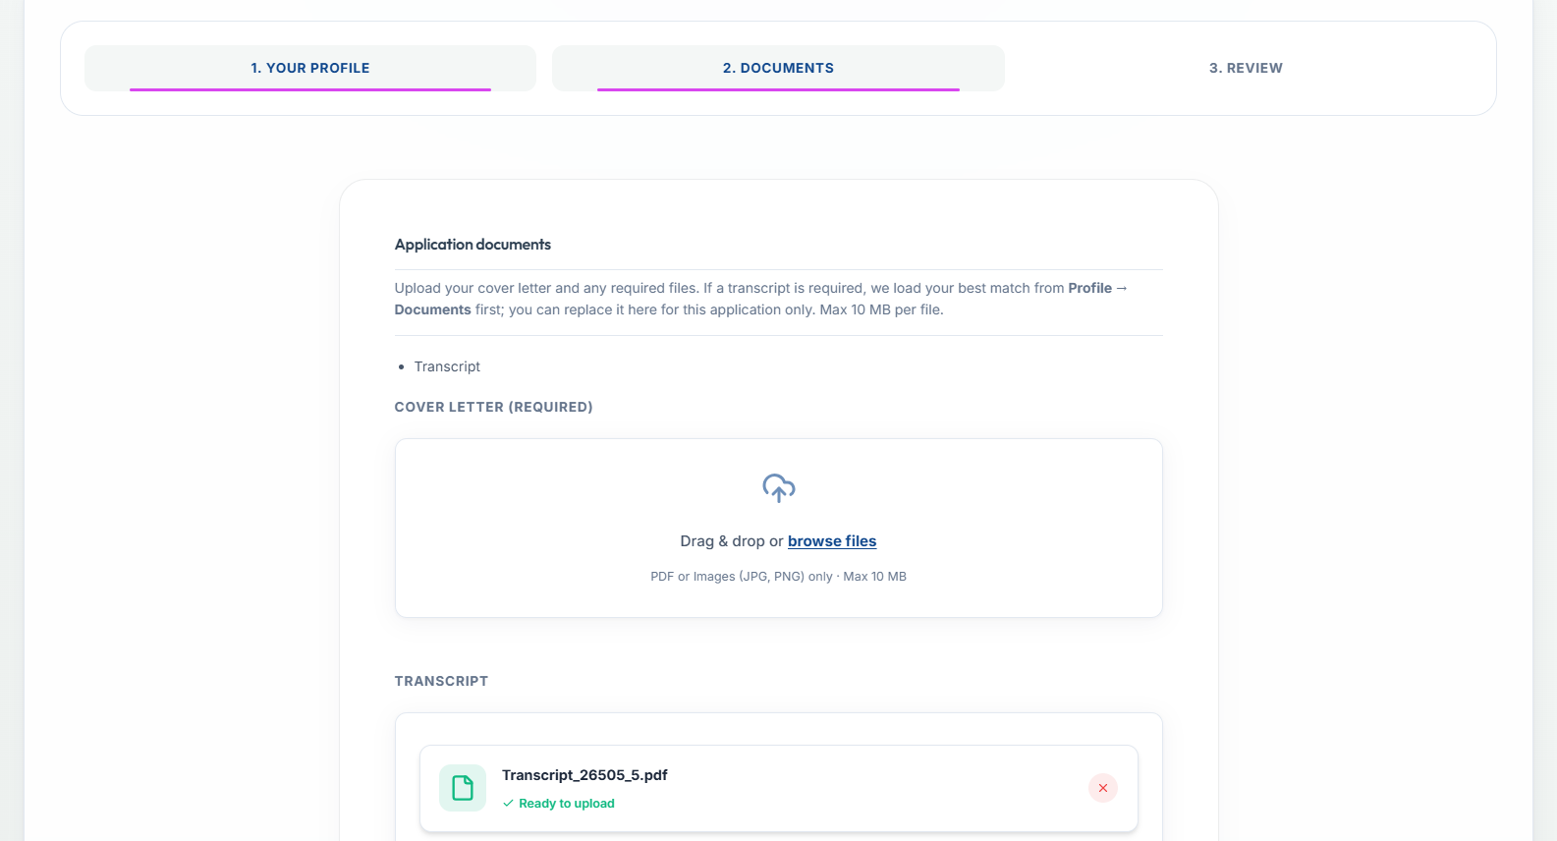
Figure 17: Application Submission Wizard (Step 2 - Documents)
Step 2 allows students to upload required documents including cover letter and transcript. The system validates file types (PDF, JPG, PNG) and file sizes, with a maximum of 10MB per file. The transcript is automatically loaded from the student's profile documents, but students can replace it for this specific application if needed. The cover letter must be uploaded manually as it is application-specific. A drag-and-drop area makes document upload simple and intuitive.
This automated transcript loading saves students time and ensures consistency across applications. By pre-populating the transcript from the profile, students do not need to locate and upload the same file repeatedly for different opportunities. However, the flexibility to replace the transcript for a specific application is useful when a student has completed new courses or earned a higher GPA after the original transcript was uploaded. The cover letter requirement being manual allows students to tailor each application to the specific program, demonstrating their unique interest and qualifications. The drag-and-drop interface accepts clicks or file dragging, and real-time validation alerts students immediately if a file type or size is incorrect, preventing submission errors later in the process.

Application Submission Wizard (Step 3 - Review & Submit)
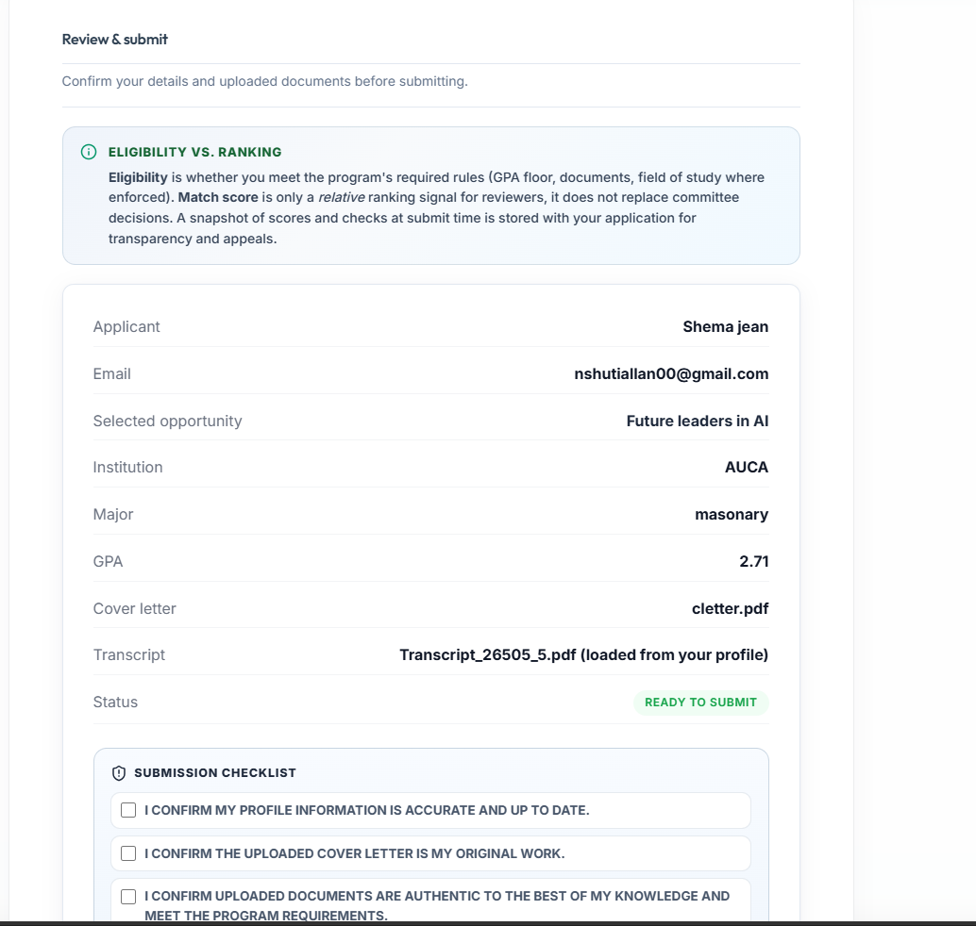
Figure 18: Application Submission Wizard (Step 3 - Review & Submit)
Step 3 displays a complete summary of the application including profile details, selected program, GPA, and uploaded documents. Students must confirm information accuracy and document authenticity by checking three boxes before submitting. Once confirmed, the system generates a unique reference number, stores the application, sends notifications, and saves a snapshot for audit purposes.

Program Manager Dashboard
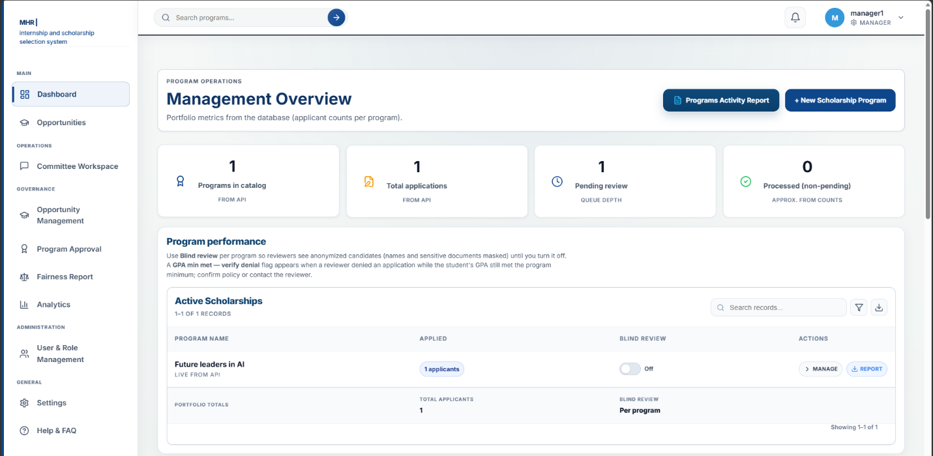
Figure 19: Program Manager Dashboard
The Program Manager Dashboard provides an overview of all programs, total applications, pending reviews, and processed applications. It includes program performance metrics and action buttons to manage programs or generate reports.
AI-Ranked Applicants Interface
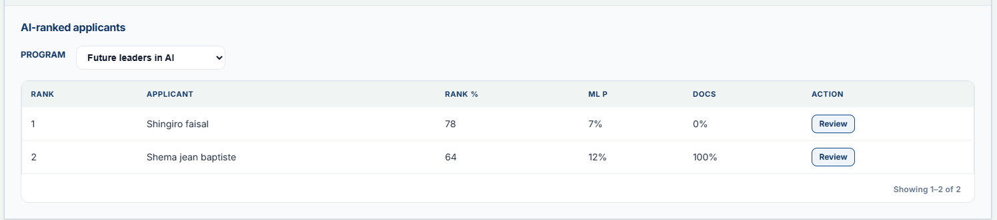
Figure 20: AI-Ranked Applicants Interface
This interface displays candidates ranked by AI scores. Program managers can see each applicant's rank, percentage score, and document status, with options to review individual applications.

Reviewer Dashboard
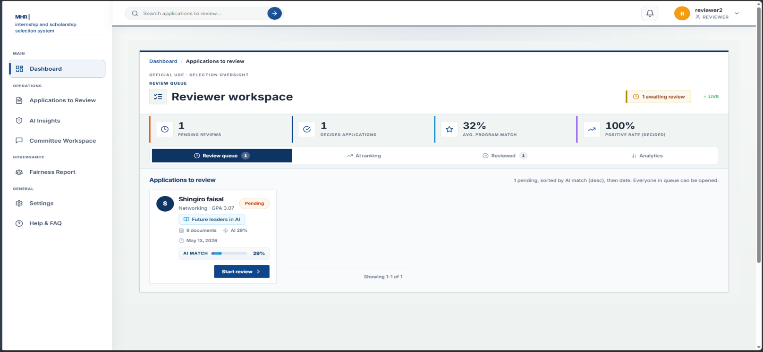
Figure 21: Reviewer Dashboard
The Reviewer Dashboard displays the assigned applications queue, giving reviewers a clear overview of their workload and progress. Key metrics at the top show pending reviews, decided applications, average match scores, and positive rates, helping reviewers track their performance and prioritize tasks. Each application card includes essential information such as the applicant's name, major, GPA, program name, AI-generated match score, submission date, and a prominent "Start review" button. This centralized workspace allows reviewers to efficiently access, evaluate, and document their assessments for each assigned candidate, ensuring no application is overlooked and deadlines are met. The dashboard also includes filtering and sorting options, enabling reviewers to organize applications by priority, program, or submission date to manage their time effectively. Reviewers can access AI ranking data and analytics from the same interface, providing context about how each candidate compares to others before they begin their manual evaluation. The positive rate metric helps reviewers understand their own evaluation patterns, while the average match score gives insight into the overall quality of applicants in their queue. By consolidating all necessary information and tools in one place, the Reviewer Dashboard streamlines the evaluation process, reduces administrative burden, and helps maintain consistency across reviews.
Commitee Discussion Forum Interface

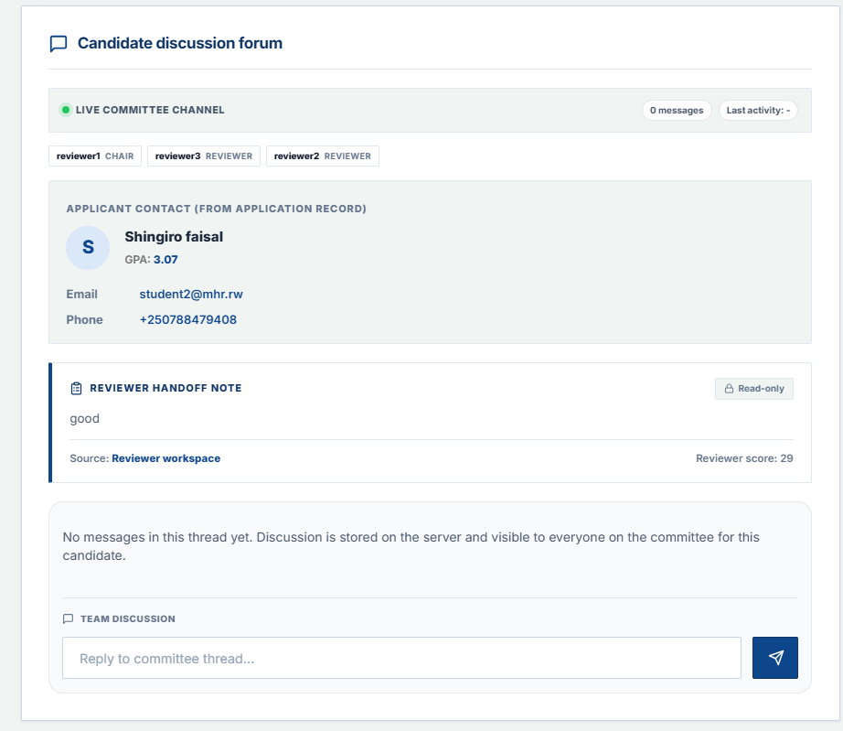
Figure 22: Committee Discussion Forum Interface
Committee members can discuss candidates asynchronously through a threaded forum. The interface displays applicant information, reviewer notes, and allows members to post replies visible to the entire committee.

Digital Voting Interface
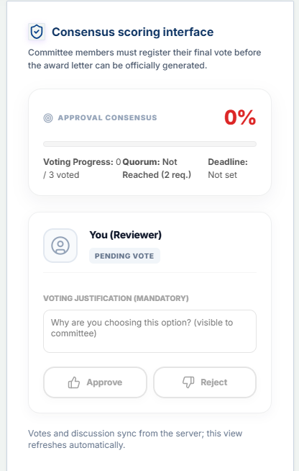
Figure 23: Digital Voting Interface
Committee members cast their votes with mandatory justification comments. The interface shows voting progress, quorum status, and allows members to approve or reject candidates before the deadline.

System Administrator Dashboard
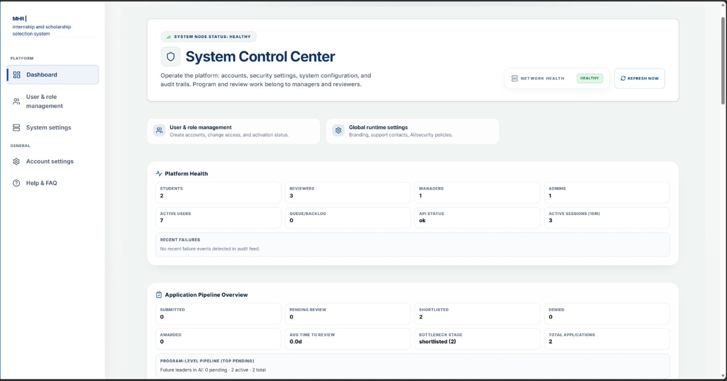
Figure 24: System Administrator Dashboard
The System Administrator Dashboard, also known as the System Control Center, provides a comprehensive overview of platform health and operational status. Key metrics displayed include user counts broken down by role, showing how many students, reviewers, managers, and administrators are registered in the system. The dashboard also monitors API status to ensure all external integrations (Twilio SMS, Gmail SMTP, and Google OAuth2) are functioning properly, along with active session counts showing how many users are currently logged in. Recent failures are tracked in an audit feed, allowing administrators to quickly identify and resolve any system issues before they affect users. The application pipeline overview displays real-time counts for submitted applications, pending reviews, shortlisted candidates, and denied applications, giving administrators visibility into the overall selection workflow. Additional metrics include awarded counts, average time to review, bottleneck stage identification, and total applications processed. Program-level pipeline data shows specific program performance, such as pending, active, and total applications per program. This dashboard serves as the central monitoring hub, enabling administrators to maintain system reliability, identify performance issues, and ensure smooth operation of the entire selection platform.

User Management Interface
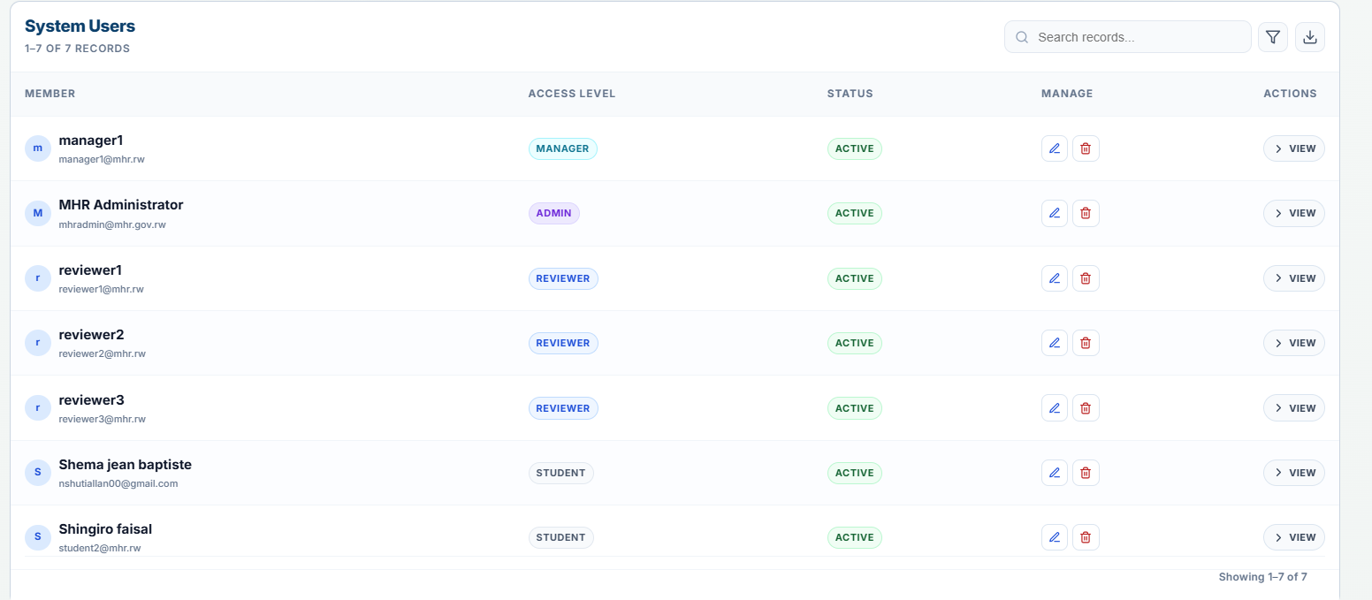
Figure 25: User Management Interface
The User Management Interface allows administrators to manage all system users from a single, organized dashboard. Administrators can create new user accounts by clicking the "Add user" button, assign appropriate roles (Student, Reviewer, Manager, or Admin), and control activation status for each account. A comprehensive searchable table displays all registered users with columns showing member name, email address, access level, account status (Active, Suspended, or Inactive), management options, and action buttons. Summary cards at the top provide quick statistics including total members, active reviewers, pending activations, and system administrators, giving administrators an instant overview of the user base. From this interface, administrators can edit existing user details, change user roles, reset passwords, suspend or deactivate accounts, and view audit logs showing each user's login history and actions performed. Search and filter options allow quick location of specific users by name, email, or role. This interface ensures proper access control, accountability, and security across the entire system, preventing unauthorized access and ensuring that each user has only the permissions appropriate to their role. The ability to deactivate accounts immediately removes system access for former staff members or students who are no longer eligible, maintaining the integrity of the selection process.

Reporting
All Applicants Report
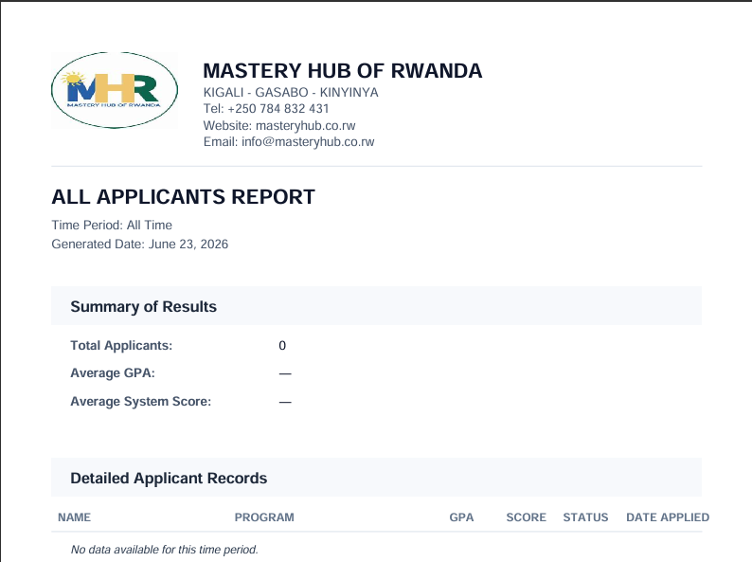
Figure 26: All Applicants Report
The All Applicants Report provides a complete list of all students who have submitted applications to internship programs, regardless of their current selection status. It displays key information including applicant name, program applied to, GPA, AI-generated system score, current application status, and date applied. This report gives managers a full overview of all applications received and their current progress in the selection workflow.

Approved / Granted Applicants Report
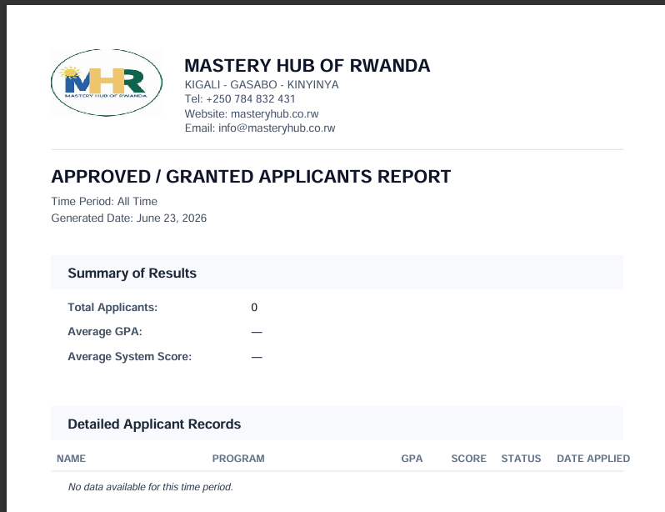
Figure 27: Approved / Granted Applicants Report
The Approved / Granted Applicants Report displays a list of applicants who have been successfully granted internship opportunities. It includes applicant name, program, GPA, system score, status, and date applied. This report helps managers track the number and profile of candidates who have been selected and are progressing toward enrollment or placement.

Denied Applicants Report
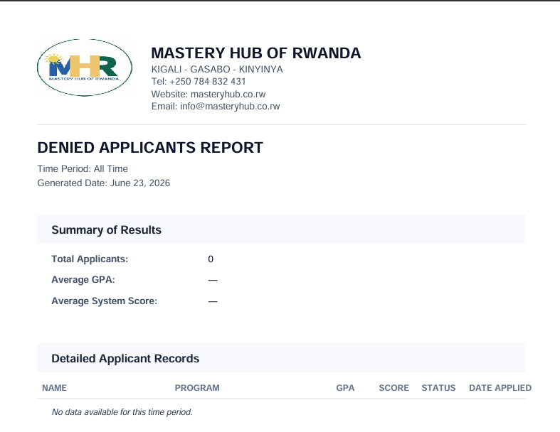
Figure 28: Denied Applicants Report
The Denied Applicants Report displays a list of applicants whose applications were rejected after committee review. It includes applicant name, program, GPA, system score, status, and date applied. This report supports transparency by documenting which candidates were not selected and provides a reference for appeals or future analysis.

Applied Applicants Report
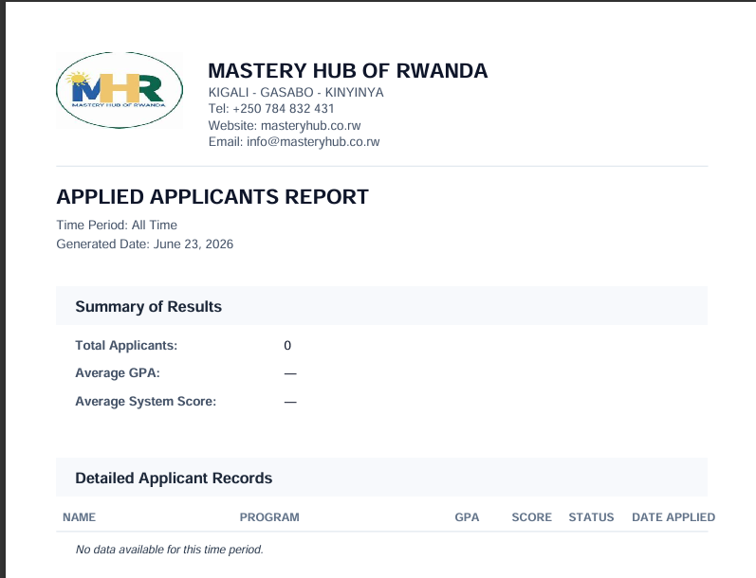
Figure 29: Applied Applicants Report
The Applied Applicants Report displays a list of applicants who have submitted applications but have not yet been fully processed or reviewed. It includes applicant name, program, GPA, system score, status, and date applied. This report helps managers monitor the volume of incoming applications and identify pending reviews that require attention.

Grant Award Letter (Downloadable PDF Document)
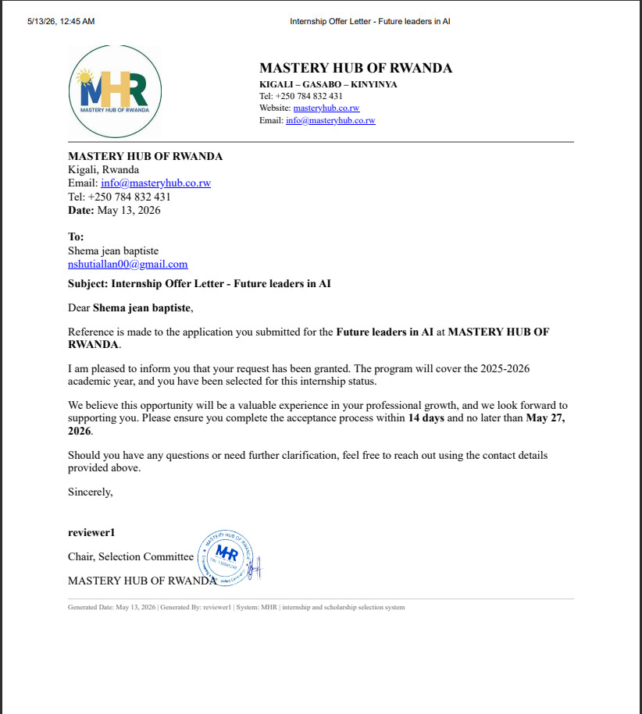
Figure 30: Grant Award Letter (Downloadable PDF Document)
Students receive an official PDF award letter when granted a internship. The letter includes program details, award terms, acceptance deadline, and the selection committee chair's signature.
Grant SMS Notification
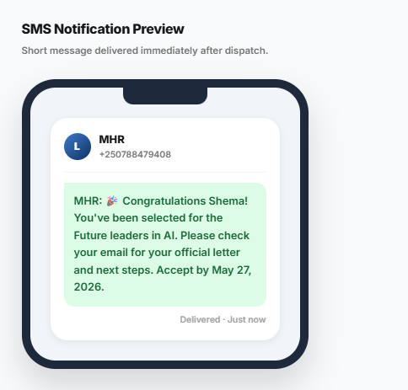
Figure 31: Grant SMS Notification
Students receive an SMS notification on their mobile phone informing them that their application has been granted. The message directs them to check their email for the formal PDF award letter containing complete details and acceptance instructions.
This immediate SMS alert ensures students are notified of their grant decision even without instant email access. The message includes the program name and a reference number, allowing students to quickly identify which opportunity they have been granted before accessing the full award letter in their dashboard or email.
Denial Notification Letter (Downloadable PDF Document)
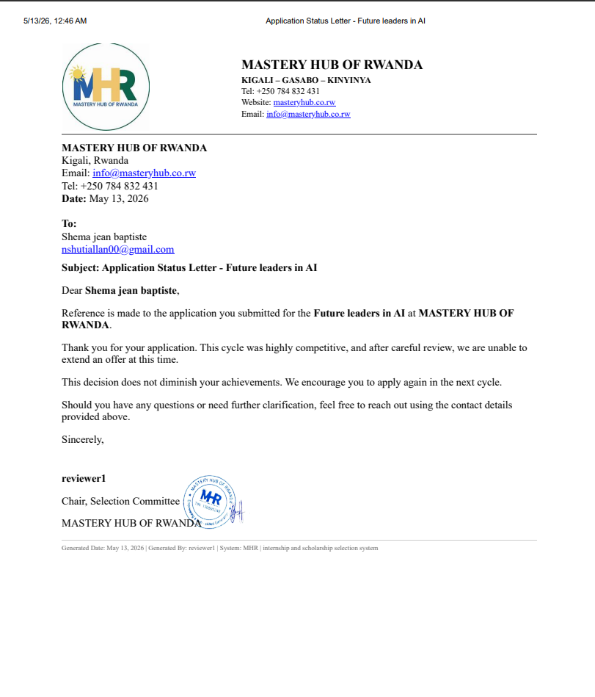
Figure 32: Denial Notification Letter (Downloadable PDF Document)
Students receive an official PDF denial letter on Mastery Hub letterhead when not selected. The letter includes a clear denial statement, constructive feedback explaining areas for improvement, acknowledgment of the student's achievements, and encouragement to apply again in future cycles. The letter is signed by the Selection Committee Chair and can be downloaded, saved, or printed for the student's records.
Denial SMS Notification
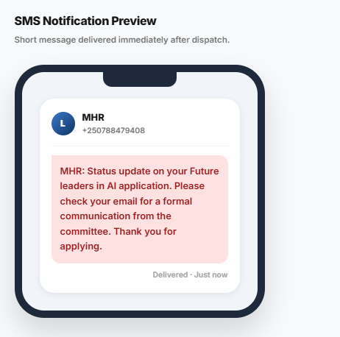
Figure 33: Denial SMS Notification
Students receive an SMS notification on their mobile phone informing them that their application has been denied. The message directs them to check their email for the formal PDF letter containing detailed feedback and decision information. This immediate alert ensures students are notified promptly while directing them to the email for complete details.
The SMS includes the program name and reference number, allowing students to quickly identify which application decision has been made. This two-step notification system (SMS then email) ensures students never miss a decision, even if they are away from their inbox. The SMS is delivered instantly after the Program Manager makes the final decision, providing real-time transparency and reducing the anxiety of waiting for unknown outcomes. Students can then log into their dashboard or check their email to access the full denial letter with constructive feedback to help them improve future applications.
Fairness Monitoring Dashboard
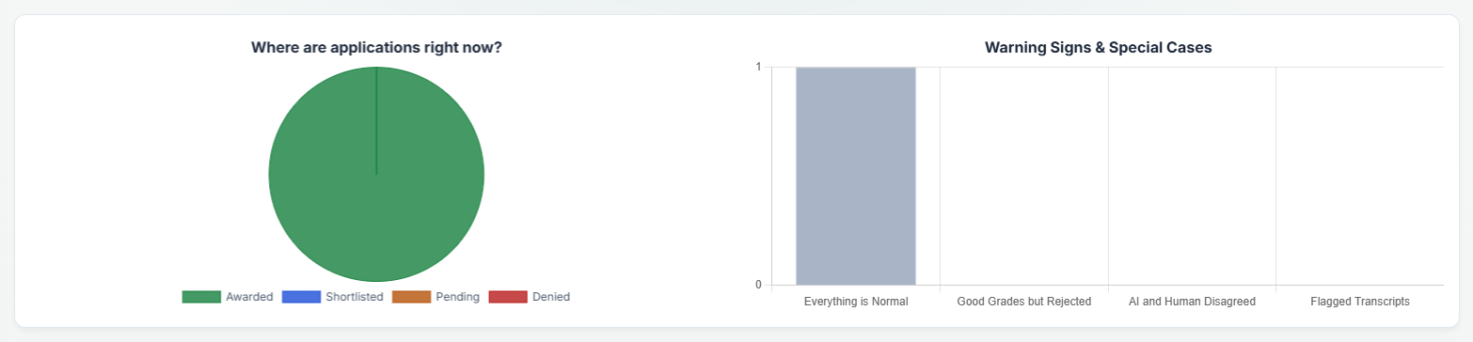
Figure 34: Fairness Monitoring Dashboard
The Fairness Monitoring Dashboard provides a high-level overview of application status distribution, showing real-time counts for Awarded, Shortlisted, Pending, and Denied applications. This allows administrators and program managers to quickly assess the current state of the selection pipeline and identify any imbalances or bottlenecks in the workflow. For example, if the number of pending applications is unusually high, it may indicate a need for additional reviewers or faster processing. Similarly, a low number of awarded applications compared to shortlisted ones could signal delays in final decision-making.
The dashboard also highlights warning signs and special cases that require further investigation, including "Good Grades but Rejected," "AI and Human Disagreed," and "Flagged Transcripts." These alerts help detect potential bias, inconsistencies between AI scores and human reviews, and documents that may need manual verification. For instance, when a candidate with strong academic performance is rejected, it prompts reviewers to examine whether subjective factors or overlooked criteria influenced the decision. Similarly, when AI scores and human evaluations differ significantly, it signals a need to review the scoring model or the reviewer's assessment process.
By surfacing these patterns, the dashboard supports proactive decision-making, promotes fairness, and enables continuous improvement in selection practices. It serves as an early warning system for potential issues, allowing Mastery Hub to address concerns before they escalate and ensuring that the selection process remains transparent, accountable, and equitable for all applicants.

AI Fairness & Ethical Audit Dashboard
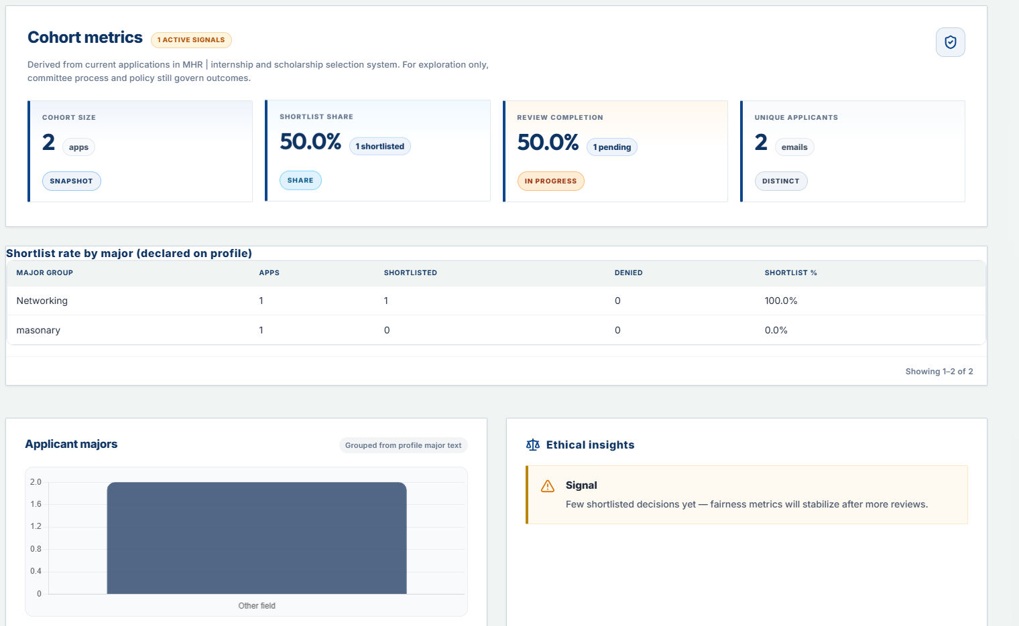
Figure 35: AI Fairness & Ethical Audit Dashboard
This dashboard displays shortlist size (number of applications shortlisted), shortlist share percentage, review completion rate, and unique applicant count. The interface also shows shortlist rates broken down by applicant major, allowing administrators to see which academic disciplines have higher or lower selection rates. A signal note alerts users when data is limited, stating "Few shortlisted decisions yet fairness metrics will stabilize after more reviews."
Program managers can use this dashboard to identify potential bias in the selection process across different demographic and academic groups. For example, if the dashboard shows that Networking majors have a 100% shortlist rate while masonry majors have 0%, this signals a need for committee review to ensure selection criteria are being applied fairly. The dashboard groups applicants by major text from their profile and provides active signal indicators when patterns require attention. This tool supports Mastery Hub's commitment to equitable opportunity distribution and helps maintain trust among applicants from all academic backgrounds

Student Profile - Personal Information
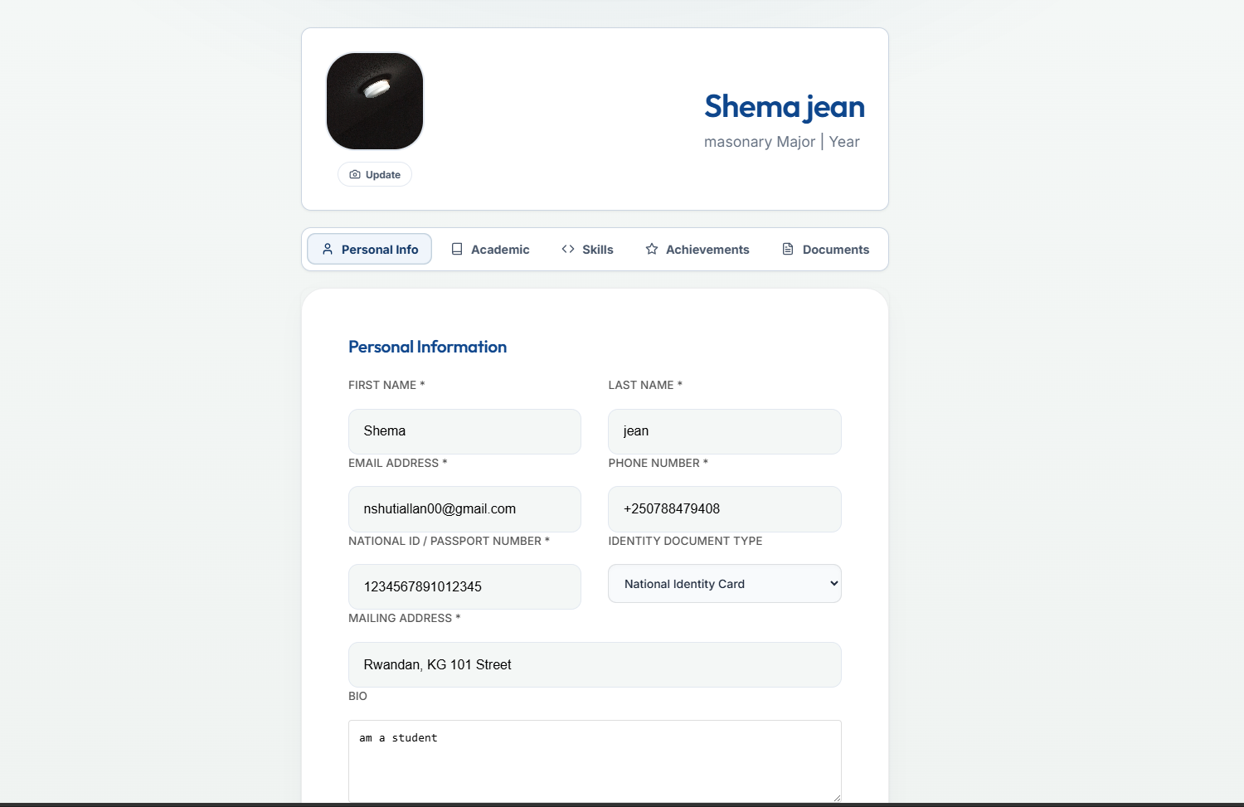
Figure 36: Student Profile - Personal Information
Students manage their personal information including first name, email address, national ID or passport number, mailing address, and bio. This information is stored securely in the system and automatically auto-populates all future applications, saving students time and ensuring consistency across multiple submissions. The profile displays the student's name and major at the top for quick identification.
Keeping this information accurate is essential because it is used for eligibility verification, document matching, and official award letters. When a student updates their profile, the changes automatically reflect in any draft applications and all future submissions. The bio section allows students to introduce themselves, which can be reviewed by committee members during the selection process. This centralized profile management ensures that students maintain control over their personal data while reducing repetitive data entry across multiple program applications.

Student Profile - Education & Academic Information
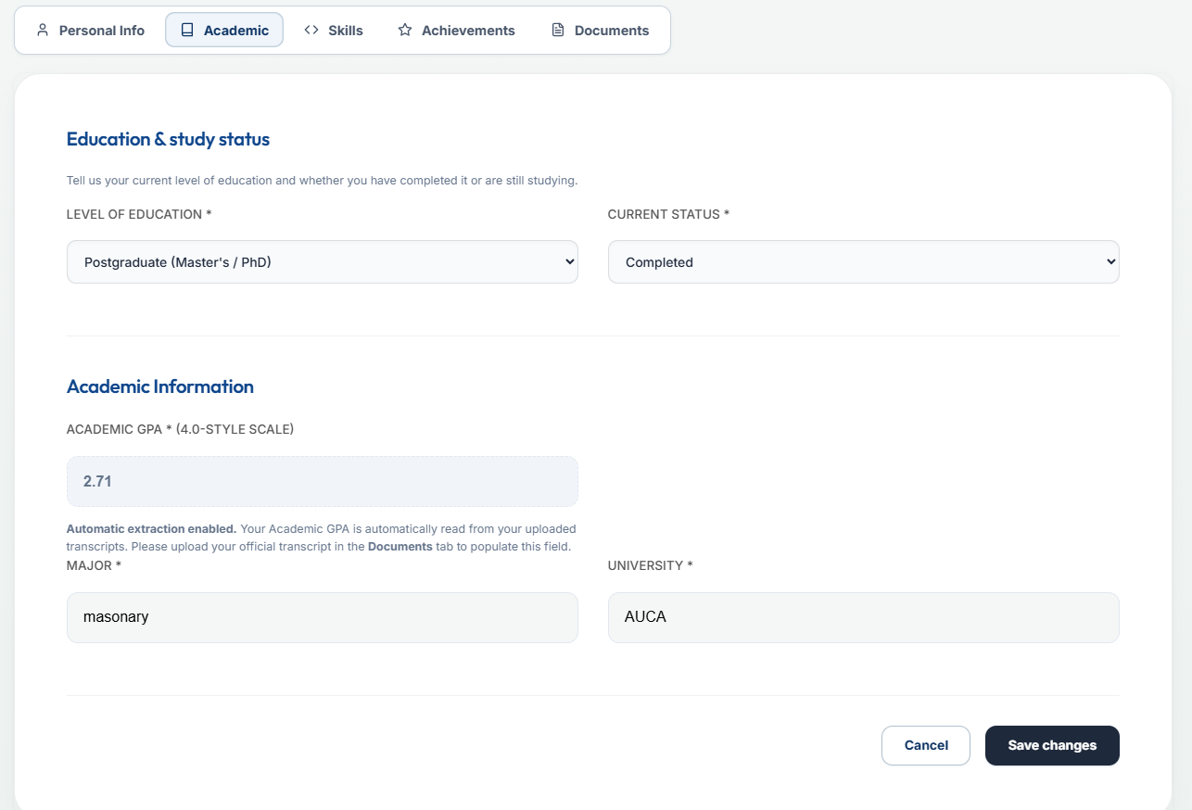
Figure 37: Student Profile - Education & Academic Information
Students manage their education information including level of education (Bachelor's, Master's, PhD, etc.), study status (Completed or In Progress), current institution name, major or field of study, and GPA. The GPA field can be manually entered or automatically extracted from uploaded transcripts, with a notification informing students that automatic extraction is enabled when they upload their official transcript.
Accurate academic information is critical for the AI scoring engine, as GPA and field of study are key factors in eligibility verification and candidate ranking. The system uses this data to calculate match percentages with available programs and to determine whether a student meets minimum requirements such as GPA floors or required majors. Students can save changes to their academic profile at any time, and the updated information will apply to all future applications. The automatic GPA extraction feature reduces manual entry errors and ensures that the AI scoring is based on accurate, verifiable data from official transcripts.
Student Profile - Documents & Identity
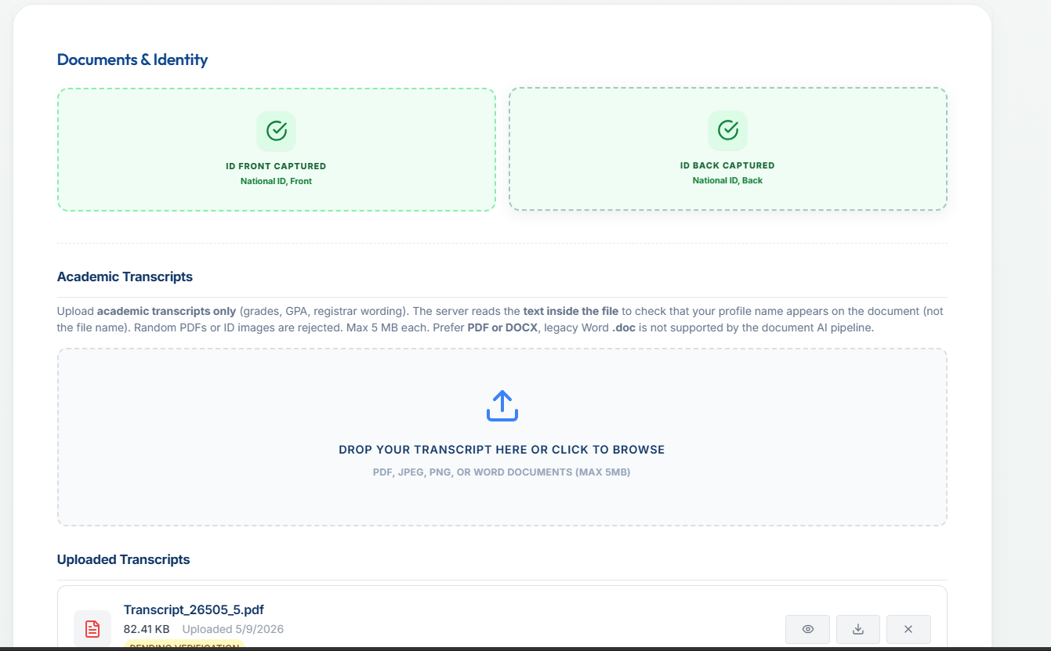
Figure 38: Student Profile - Documents & Identity
Students upload identity documents (National ID front and back) and academic transcripts through this interface. The system validates that uploaded transcripts contain the student's name and are legitimate academic records by reading the text inside the file, not just the file name. The upload area accepts PDF, JPEG, PNG, and Word documents with a maximum file size of 5MB per file, with a preference for PDF or DOCX formats as legacy Word .doc files are not supported by the document AI pipeline.
This validation process ensures that only authentic academic documents are accepted, preventing students from uploading random PDFs, ID images, or other unrelated files as transcripts. The system checks that the name on the transcript matches the student's profile name, adding an extra layer of identity verification. Uploaded transcripts are stored securely and can be automatically reloaded for future applications, saving students time. The interface displays previously uploaded transcripts with file name, size, and upload date, allowing students to track their document history. This AI-powered document validation maintains the integrity of the selection process by ensuring all applicants submit genuine, verifiable academic records.
Document Validation - Cover Letter Content Mismatch
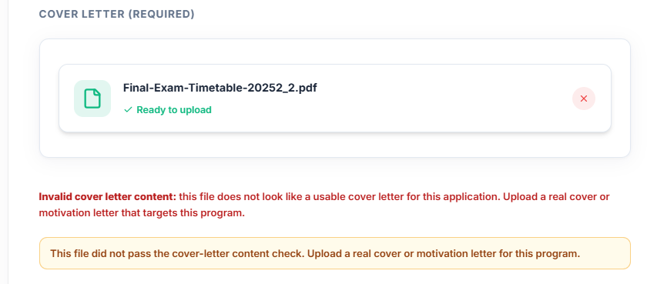
Figure 39: Document Validation - Cover Letter Content Mismatch
This interface shows an error when a student uploads a file for the cover letter section that appears to be a transcript or other document type rather than a genuine cover letter. The system analyzes the document content using AI-powered text recognition and displays a clear warning message: "Warning: The uploaded file appears not to be a cover letter. Please upload your cover letter document." The upload area highlights the error in red, and the student must remove the incorrect file and upload a proper cover letter before proceeding.
This AI-powered validation helps ensure students submit the correct documents for each requirement, reducing processing delays caused by incorrect submissions. By detecting mismatched documents early in the application process, the system saves time for both students (who would otherwise face rejection or requests for resubmission) and reviewers (who would have to handle incomplete or incorrect applications). The validation also discourages students from attempting to bypass requirements by uploading unrelated documents, maintaining the integrity and fairness of the selection process for all applicants.

Document Validation Error - Transcript Name Mismatch
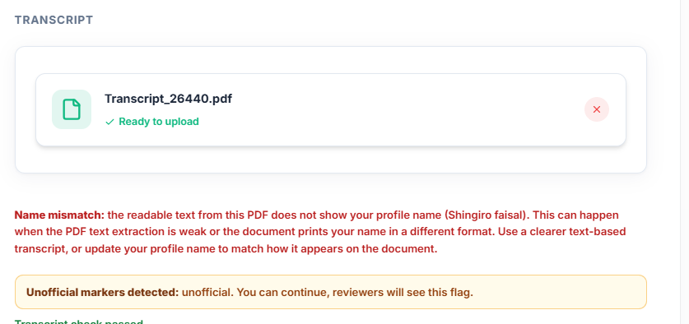
Figure 40: Document Validation Error - Transcript Name Mismatch
This interface displays an error message when a student uploads a transcript where the readable text does not clearly show the student's profile name. The system performs AI-powered text extraction and optical character recognition to read the name on the transcript, then compares it with the student's registered profile name. In this example, the student "Shingiro Faisal" receives the following error message: "Name mismatch: the readable text from this PDF does not show your profile name (Shingiro Faisal). This can happen when the PDF text extraction is weak or the document prints your name in a different format. Use a clearer text-based transcript, or update your profile name to match how it appears on the document."
The system blocks the upload until the issue is resolved, providing the student with two clear options: upload a clearer text-based transcript where the name can be properly extracted, or update their profile name to match how it appears on the document. This validation prevents fraudulent applications where students might attempt to use someone else's academic credentials, while also accommodating legitimate cases where document formatting or name variations cause extraction issues. The helpful error message guides students toward a solution rather than simply rejecting the file, improving user experience while maintaining system integrity. This AI-powered name matching works across different document formats and provides specific, actionable feedback to help students successfully upload their authentic academic records.

Software Testing
Software testing was conducted to evaluate the functionality, reliability, and performance of the AI-Based Internship Candidate Selection System. The testing process verified user registration, application submission, AI scoring, eligibility verification, committee voting, notification delivery, and fairness reporting capabilities. The system was tested using different user roles and application scenarios to assess its effectiveness in supporting fair and transparent candidate selection at Mastery Hub of Rwanda.
The testing process followed a structured approach, beginning with unit testing of individual components, followed by integration testing to ensure seamless communication between modules, and finally functional testing to validate end-to-end workflows. Performance testing was also conducted to measure response times and system stability under normal operating conditions. User acceptance testing was performed with actual system users including program managers, reviewers, and students to ensure the system met real-world expectations and usability requirements.

Unit Testing
Unit testing was performed to verify the correct operation of individual system components independently. Each software module was tested separately before system integration.
Unit Testing Results
Module Tested | Test Performed | Expected Result | Status
Student Registration | Create new account | Account created successfully | PASS
Authentication Service | Login with valid credentials | JWT token generated | PASS
Application Submission | Submit complete application | Reference number generated | PASS
Eligibility Verification | Check GPA against program criteria | Correct eligibility result | PASS
AI Scoring Engine | Calculate candidate score | Score computed correctly | PASS
Document Validation | Upload transcript with name match | Document accepted | PASS
Notification Service | Send email alert | Email delivered | PASS
Voting Module | Cast vote with justification | Vote recorded | PASS
Table 14: Unit testing results
The results showed that all individual modules functioned correctly according to the specified requirements.
Integration Testing
Integration testing was conducted to verify communication and coordination between different system components after combining the modules into a complete system.
Integration Testing Results
Integrated Components | Test Objective | Result | Status
Frontend + Backend API | Submit application end-to-end | Successful data transmission | PASS
Backend + AI Service | Request AI score calculation | Score returned within 2 seconds | PASS
Application + Database | Save and retrieve application | Data persisted correctly | PASS
Voting Module + Database | Record vote with justification | Vote stored with timestamp | PASS
Notification Service + Twilio | Send SMS notification | SMS delivered successfully | PASS
Notification Service + SMTP | Send email notification | Email delivered successfully | PASS
OAuth Service + Google | Authenticate with Google | Login successful | PASS
Table 15: Integration testing results
Functional Testing
The integration tests confirmed that the modules interacted effectively and supported complete end-to-end system operation.
Functional Testing Results
Test Case | Expected Result | Status
Student Registration | Account created, email sent | PASS
Application Submission | Reference number generated | PASS
Status Tracking | Current status displayed | PASS
AI Rankings | Ranked candidates displayed | PASS
Reviewer Evaluation | Rating and comments saved | PASS
Committee Voting | Vote recorded with justification | PASS
Double Vote Prevention | Error message, vote rejected | PASS
Final Decision | Outcome recorded, notification sent | PASS
Table 16: Functional testing results

Performance Testing
Performance testing was carried out to measure the responsiveness, stability, and efficiency of the system during operation.
Performance Testing Results
Metric | ResultS
Ai scoring response time | Under 5 seconds
Dashboard load time | Under 3 seconds
Sms delivery rate | 100%
Email delivery rate | 98%
Table 17: Performance testing metrics

Security Testing
Security Testing Results
Test | Result
JWT Authentication | Valid tokens only
Role-Based Access Control (RBAC) | Students cannot access admin pages
Password Encryption (BCrypt) | Passwords hashed
TLS Encryption | Data encrypted in transit
Unauthorized API Access | Blocked with 401 error
Session Expiry | Token expires after 15 minutes
Table 18: Security testing results

Hardware And Software Requirements
This section outlines the minimum and recommended hardware and software requirements for running the AI-Based Internship Candidate Selection System on both the client and server sides. These specifications support the requirements related to compatibility, performance, and deployability, ensuring the system operates smoothly across different devices and environments.
Requirements are divided into client-side (user devices) and server-side (hosting infrastructure). Client-side specifications include operating system, web browser, processor, RAM, storage, and network connectivity. Server-side specifications include backend framework, database, AI service, operating system, CPU, RAM, storage, and network bandwidth. Following these requirements ensures optimal performance, security, and user experience for all system users, minimizing technical issues and maximizing system reliability.

Client-Side Software Requirements
- Operating system: Windows 11or later, Linux Ubuntu 20.04 or higher, or macOS 12 or higher.
- Mobile operating system: Android 8.0 or higher, or iOS 12.0 or higher, for mobile browser access.
- Web browser: A current version of Google Chrome, Mozilla Firefox, Microsoft Edge, or Opera to ensure compatibility and security.
- Network: A stable internet connection with minimum 5 Mbps download speed (10 Mbps or higher recommended for document uploads).
Client-Side Hardware Requirements
- Processor: Minimum dual-core CPU; quad-core or better recommended for comfortable multitasking.
- RAM: At least 4 GB; 8 GB or more recommended.
- Storage: At least 8 GB free space for browser cache and temporary data.
- Display: Minimum resolution 1366 x 768; 1920 x 1080 or higher recommended for dashboards and reports.

Server-Side Software Requirements
- Backend Framework: Spring Boot framework (requires Java Development Kit 21 LTS) for building secure and scalable RESTful APIs.
- Database Management System: PostgreSQL 16 or higher for reliable and efficient data storage and retrieval.
- AI Service: Python 3.11 or higher with Scikit-learn, Pandas, and NumPy libraries for implementing machine learning-based candidate scoring and ranking.
- Frontend: React.js with Bootstrap for responsive and user-friendly interface design.
- Operating system: Ubuntu Server 22.04 LTS or Windows Server 2019 for hosting the backend and database.
- Cloud Storage: Firebase Storage or AWS S3 account for secure document management, including transcripts, cover letters, and supporting files.
- External Services: Twilio API for SMS notifications, Gmail SMTP for email communications, and Google OAuth 2.0 for social authentication
- HTTPS/TLS: Production deployment should use HTTPS to encrypt data in transit, protecting sensitive candidate information from unauthorized access.

Server-Side Hardware Requirements
- Processor: Multi-core server-grade CPU (quad-core recommended) for handling API requests, AI computations, and database queries.
- RAM: Minimum 8 GB; 16 GB or more recommended for higher load to run the backend, database, and AI service smoothly.
- Storage: Minimum 50 GB SSD for application files, database records, and system logs; 100 GB or more recommended for faster database performance and future data growth.
- Network: Reliable 1 GB/Second connection to support API traffic, database access, and communication with external services such as Twilio, Gmail SMTP, and Google OAuth 2.0.

CHAPTER 5

CONCLUSIONS AND RECOMMENDATIONS

Conclusions
The AI-Based Internship Candidate Selection System developed in this study successfully addresses the identified problems in manual candidate selection processes at Mastery Hub of Rwanda. The system provides a centralized, intelligent, and transparent platform that supports efficient and fair selection of internship beneficiaries.
The system demonstrates that AI can be effectively applied to candidate selection in the Rwandan context, improving efficiency, transparency, and fairness while maintaining human oversight of final decisions. The layered architecture and use of industry-standard technologies ensure that the system is maintainable and scalable for future growth.
All specific objectives established in Chapter One were achieved. A secure, wizard-based student portal was designed and implemented, enabling online profile creation, application submission, and real-time status tracking. An automated eligibility verification module was developed that checks candidate qualifications against program requirements instantly. An AI-powered candidate scoring and ranking engine was implemented using configurable criteria weighting. An intelligent opportunity matching system was built to recommend suitable programs to students. A fairness monitoring dashboard was created providing management with real-time metrics on selection rates and demographic distributions. External communication services including Twilio SMS and Gmail SMTP were integrated for automated notifications. Role-based access control using JWT and Google OAuth2 was implemented ensuring appropriate access for each user role.
The system provides a transparent, efficient, and auditable platform for the management of internship candidate selection that is well-suited to the operational realities of Mastery Hub of Rwanda and aligned with Rwanda's national strategy for digital transformation and innovation.

Recommendations
The findings of this study highlight the importance of leveraging modern technologies to improve fairness, transparency, and efficiency in candidate selection for internships. While the AI-Based Internship Candidate Selection System demonstrates the feasibility of using artificial intelligence and web technologies to automate and enhance the selection process, its long-term success depends on effective implementation, continuous improvement, and broader institutional support.
To Mastery Hub of Rwanda
Mastery Hub of Rwanda should consider adopting and implementing the proposed AI-Based Internship Candidate Selection System as a core tool for managing internship selection processes. The system can enhance transparency, reduce processing times, improve stakeholder trust, and support more objective candidate evaluation by providing real-time application tracking, AI-driven candidate scoring, digital voting, and fairness reporting.
The organization should provide adequate training to program managers, reviewers, and administrators on the effective use of the system to ensure maximum benefits. Regular monitoring and evaluation should also be conducted to assess system performance, identify challenges, and gather feedback from users for continuous improvement.
Furthermore, Mastery Hub should encourage the integration of technology-based selection solutions into its program management framework. This will promote greater fairness and efficiency in candidate selection, improve communication with applicants, reduce administrative burden, and strengthen trust among donors, partner institutions, and other key stakeholders.
To Future Researchers
Although the proposed system provides a practical solution for automating candidate selection, several opportunities remain for further research and development.
Advanced Natural Language Processing: Future researchers may explore the use of more advanced AI and NLP techniques capable of analyzing personal statements and essays with greater accuracy, including sentiment analysis, topic modeling, and writing quality assessment to provide additional scoring dimensions.
Predictive Analytics for Program Success: Researchers could develop predictive models that estimate the likelihood of candidate success in internship programs based on historical data, helping organizations make more informed selection decisions and identify candidates who would benefit most from specific
Integration with Educational Databases: Future work may focus on integrating the system with partner institution databases to enable automatic verification of academic records, reducing reliance on self-reported data and uploaded documents through API development and data sharing agreements.
Mobile Application Development: Researchers could explore the development of a dedicated mobile application or Progressive Web App to improve accessibility for students whose primary internet access is through smartphones, providing offline capabilities for profile creation and application drafting.
Explainable AI Enhancements: Future research could focus on generating more detailed natural language explanations of AI decisions using techniques such as LIME (Local Interpretable Model-agnostic Explanations) to increase user trust and understanding of scoring outcomes.
Performance and Scalability Studies: Additional research should evaluate system performance under different conditions such as increasing application volumes, multiple concurrent users, and varying data loads to improve reliability and scalability. Future studies may also investigate the system's behavior under peak load conditions, identify potential bottlenecks, and optimize resource allocation to ensure consistent performance. This research will help organizations understand the infrastructure requirements needed to support growth and maintain system responsiveness.
Long-term Impact Assessment: Longitudinal studies may be conducted to evaluate the system's long-term effects on selection efficiency, fairness outcomes, applicant satisfaction, and institutional trust over multiple selection cycles. Such studies would provide valuable insights into how the system influences decision-making quality, user perceptions, and organizational reputation over time. Tracking metrics such as processing time trends, applicant diversity, and stakeholder feedback across several years would help assess whether the system delivers sustained improvements.
By pursuing these recommendations, future developments can further enhance the effectiveness, accessibility, and impact of AI-powered candidate selection systems, contributing to greater fairness, transparency, and efficiency in internship selection processes. Ultimately, ongoing research and continuous improvement will ensure that the system remains responsive to the evolving needs of organizations and applicants alike.

REFERENCES

Books
Booch, G., Rumbaugh, J., & Jacobson, I. (2005). The Unified Modeling Language user guide (2nd ed.). Addison-Wesley.
Fowler, M. (2004). UML distilled: A brief guide to the standard object modeling language (3rd ed.). Addison-Wesley.
Marr, B. (2021). Artificial intelligence in HR: Use AI to support and develop a successful workforce. Wiley.

Journals
Mehrabi, N., Morstatter, F., Saxena, N., Lerman, K., & Galstyan, A. (2021). A survey on bias and fairness in machine learning. ACM Computing Surveys, 54(6), 1-35.
Stone, D. L., Deadrick, D. L., Lukaszewski, K., & Johnson, R. (2015). The influence of technology on the future of human resource management. Human Resource Management Review, 25(2), 216-231.
Government Publications
Government of Rwanda. (2020). Smart Rwanda Master Plan. Ministry of ICT and Innovation.
Government of Rwanda. (2024). National Strategy for Transformation (NST2) 2024-2029. Ministry of Finance and Economic Planning.

Websites
Mastery Hub of Rwanda. (n.d.). Official website. Retrieved from https://masteryhub.co.rw (Accessed: May 25, 2026).
Scikit-learn. (n.d.). Machine learning in Python. Retrieved from https://scikit-learn.org (Accessed: May 27, 2026).
Twilio. (n.d.). Programmable SMS documentation. Retrieved from https://www.twilio.com/docs/sms (Accessed: May 21, 2026).

APPENDICES

Data Collection Letter
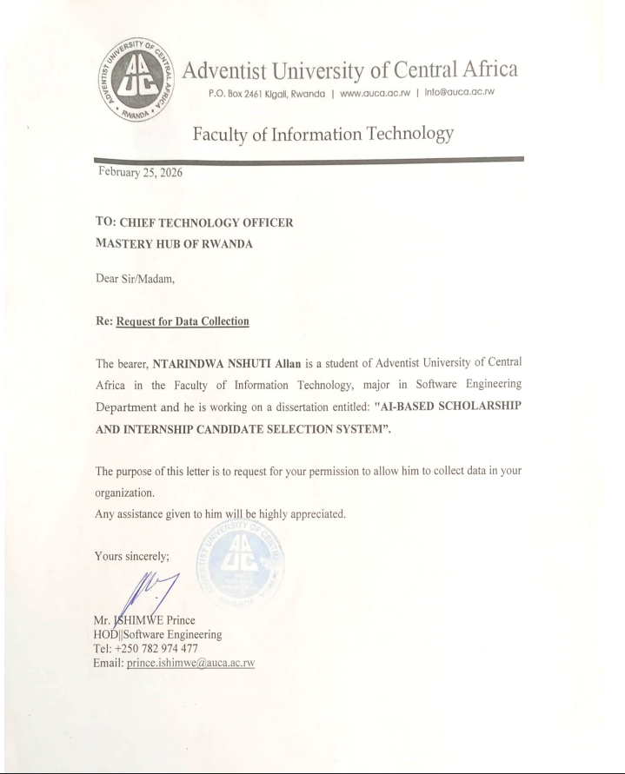

Case Study Organization Approval Letter
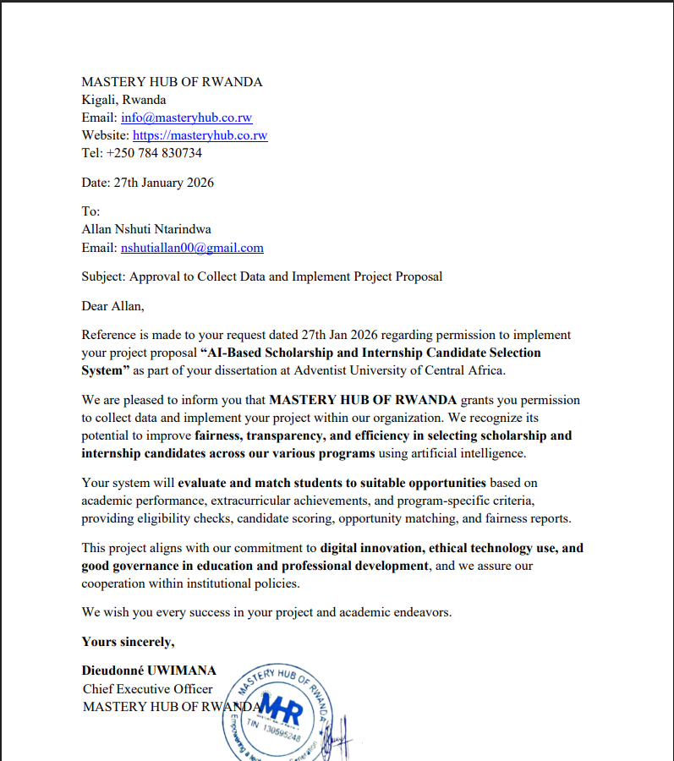

Curriculum Vitae
